WB: 17.6.19
This week we will be thinking about who the Royal Family are, where they live, what they do and how this compares to the past.  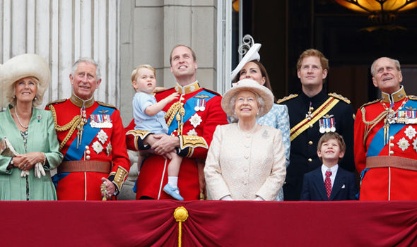 | We will be following the children’s interests about where royalty live now and in the past  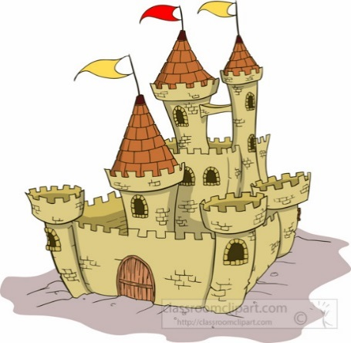 | We will be doing a range of phonics quizzes and writing sentences using the taught high frequency words.  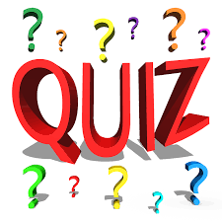
We will be continuing to count in 2’s 5’s and 10’s and will be exploring subtraction and addition and missing numbers problems.  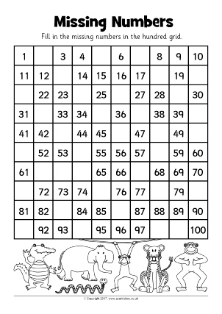 | We will be reading Royal themed books, both fact and fiction.  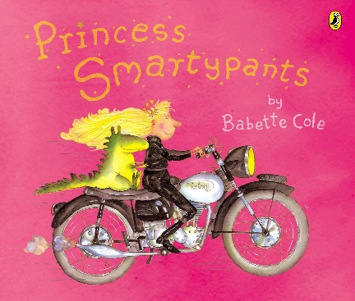 | We will be continuing to practise the skills we need for Sports Day on Friday.  Please remember that PE kits need to be in school every day and the children will need trainers or plimsolls that fit.

