WB: 3.6.19 and 10.6.19
We will be following the travels of the Gingerbread Man around the world and finding out about the different countries he visits. | We will be reading traditional tales and stories from countries around the world. | We will be writing interesting facts about the different countries visited by the Gingerbread Man.  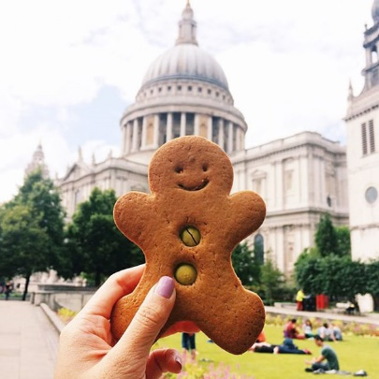
We will be continuing to count in 2’s 5’s and 10’s and will be exploring missing numbers.  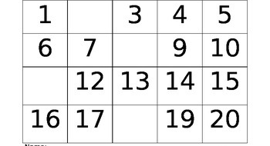 | We will be discussing time, (o’clock and half past), and thinking about what time it is in other countries around the world. | We will be starting to think about Sports Day and will be practising the skills we need on the day.  Please remember that PE kits need to be in school every day.

