Foundation Stage

Learning Adventure

Spring term 2 –Nature Explorers

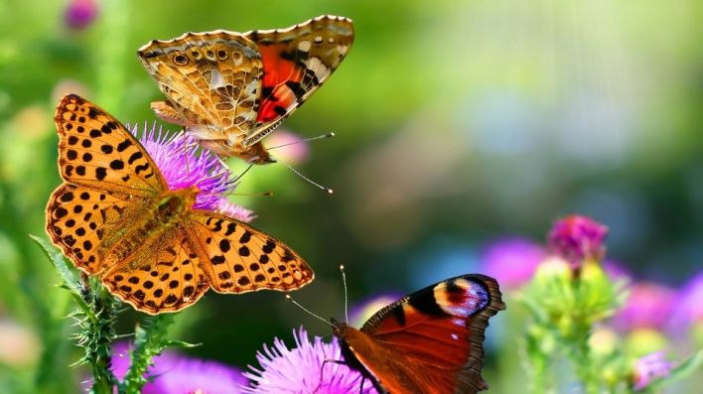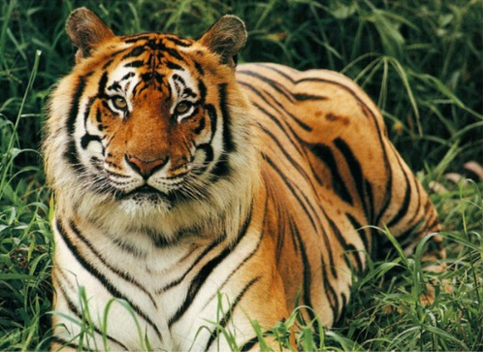 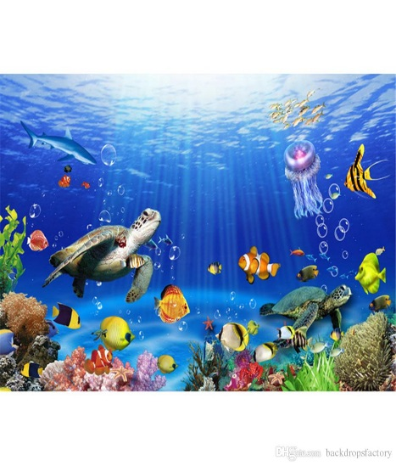 [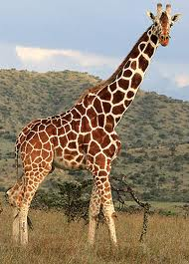](http://www.google.co.uk/imgres?q=giraffe&hl=en&gbv=2&biw=1366&bih=615&tbm=isch&tbnid=QoqqZOzi3-za4M:&imgrefurl=http://www.thesun.co.uk/sol/homepage/showbiz/tv/3219356/TV-giraffe-struck-dead-by-lightning.html&docid=WUvgQ3oXa-qp9M&imgurl=http://img.thesun.co.uk/multimedia/archive/01161/giraffe-main_1161152a.jpg&w=280&h=390&ei=Tj7zTvCfBpHY8gOYmOCdAQ&zoom=1)[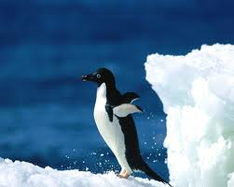](http://www.google.co.uk/imgres?q=penguin&hl=en&gbv=2&biw=1366&bih=615&tbm=isch&tbnid=W_ELxCgpVqQvuM:&imgrefurl=http://www.wallpapersgo.com/top-10-most-beautiful-penguin-wallpapers/&docid=BLt5TfCfGq2WxM&imgurl=http://www.wallpapersgo.com/wp-content/uploads/2011/09/Jump-Of-Penguin.jpg&w=1280&h=1024&ei=ED7zTrPSL82S8gOA9um3AQ&zoom=1) [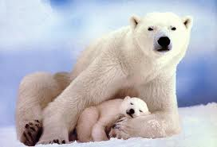](http://www.google.co.uk/imgres?q=polar+bear&hl=en&gbv=2&biw=1366&bih=615&tbm=isch&tbnid=Mx4UMfC05X8z5M:&imgrefurl=http://www.sceala.com/phpBB2/irish-forums-25517.html&docid=iOFp9PaH5n_w7M&imgurl=http://www.sceala.com/phpBB2/userpix/2_polar_bears_are_irish_1.jpg&w=640&h=436&ei=0T3zToCQO8X_8QOFjPmaAQ&zoom=1) 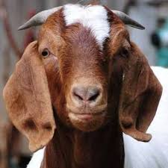



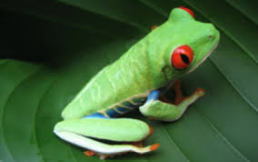

**Our topic in Foundation Stage this half term will be ‘Nature Explorers’.**

During this topic we will be finding out about animals from around the world following the children’s interests. We will explore where animals live and their different types of habitats. We will also be finding out about what animals need to survive, why they have different patterns and how they change and grow. We will also be looking closely at reusing and recycling different materials as well as the impact rubbish can have on animals and their habitats. Each class will be choosing different recyclable materials to make something different!

During this topic we will also be exploring explore mini-beasts and plants. We will be looking at the life cycles of different Mini Beasts and also discussing what both animals and plants need to grow.

In maths we will be continuing to learn about the number system and counting and reinforcing addition and subtraction. We will be learning to count in 2s, 5s and 10s. We will also begin to investigate symmetry, pattern and halving and quartering shapes. We will also be recognising and using coins.

We will explore different types of art and using a range of materials to create animal pictures. We will use ICT programmes to make images of animals. We will listen to different songs and music including ‘The Carnival of the Animals’ and create dances based around animals and big and small movements.

We will continue to look at a variety of both fact and fiction books including animal stories from other religions, as well as a variety of Bible stories – including Noah’s Ark and the story of Easter and Aesop’s Fables. We will also be writing our own versions of some of our favouirite stories including The very hungry caterpillar.

This half term we will be looking at various authors including Julia, Donaldson, Nick Butterworth, Nick Sharrett and Eric Carle, so please look out for these books at the library and share some of them together at home.

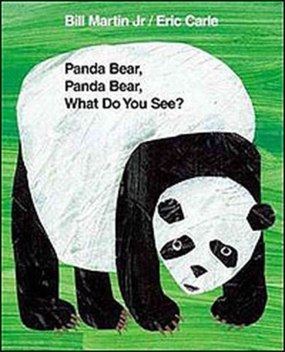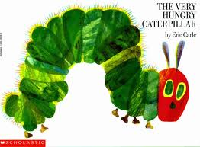[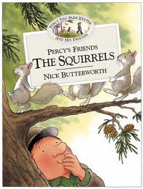](http://www.google.co.uk/imgres?q=nick+butterworth&hl=en&biw=1366&bih=615&gbv=2&tbm=isch&tbnid=RK2wYa3sQD0YHM:&imgrefurl=http://www.harpercollins.co.uk/Titles/16321/percys-friends-the-squirrels-nick-butterworth-9780007119806&docid=VeFPcB517ivrzM&imgurl=http://images.harpercollins.co.uk/hcwebimages/hccovers/016300/016321-FC50.jpg&w=500&h=658&ei=g0nzTtPEHY2o8AO1-dnCAQ&zoom=1)

Places to Visit

**Tring Museum**,   
The Walter Rothschild building  
Akeman Street  
Tring  
Hertfordshire  
HP23 6AP

**Whipsnade Zoo**

ZSL Whipsnade Zoo  
Dunstable  
Bedfordshire LU6 2LF

**Natural History Museum**

Cromwell Road, South Kensington, London

<http://www.nhm.ac.uk/>

**Kew Gardens**

Kew Gardens is located at Kew, Richmond, Surrey, TW9 3AB

<http://www.kew.org>

**Waddesdon Manor**

Waddesdon, Nr Aylesbury, Buckinghamshire, HP18 OJH

01296 653226

<http://www.waddesdon.org.uk/>

Please let us know if you discover any other worthwhile places to visit!

Useful websites:

http://www.dltk-kids.com/animals/

<http://www.enchantedlearning.com/subjects/animals>

<http://www.woodlands-junior.kent.sch.uk/besmart/animals.html>

<http://www.rspca.org.uk/education/utilities/gallery/contents/-/album/WildAnimals>

http://www.bbc.co.uk/schoolradio/subjects/english/aesops_fables

<http://www.eric-carle.com/home.html>

<http://www.highlandschools-virtualib.org.uk/primary_curriculum/minibeasts.htm>

<http://www.bbc.co.uk/cbeebies/somethingspecial/stories/mrtumbleandtheminibeasts/>

<http://www.dltk-kids.com/crafts/insects/index.htm>

<http://tlc.howstuffworks.com/family/easy-water-activities-for-kids.htm>

<http://www.kidzone.ws/water/>

A**ctivities for Parents and Children to share at home**

The activities listed below are suggestions for things you might like to try with your child at home. The activities will complement the work we are doing in class. It is not expected that everyone will try all of the activities.

* Make an animal sculpture out of plasticine, play dough boxes, paper or cardboard.
* Collect some natural materials such as stones, leaves and sticks. Use them to make a collage of an animal.
* Paint or draw a picture of your favourite animal.
* Make up an animal story to tell
* Research about the different animals and create a fact file about them to share.
* Make an animal or mini beast mask
* Gather animal toys or pictures – put into order of height, smallest to tallest, sort into groups – big and small or challenge to think of own ways to sort
* Find out the names of animals and their babies
* Count in twos, just like Noah counted the animals in his Ark
* Make an animal home or a bug hotel.
* Make an egg box caterpillar.
* Print finger print bees and some flowers for them to visit.
* Learn a song or rhyme about a bug or a slug.
* Go on a butterfly, caterpillar or mini beast hunt in your garden – www.naturedetectives.org.uk
* Make a weather chart for the week and plot the weather.
* Fill glass jars with differing amounts of water and hit them with a spoon. Discuss why they make different sounds.
* Plant some seeds and watch them grow.
* Make a diary of your plants as they grow.

# Animal Sock Puppets

# Sock puppets inspire hours of imaginative play.

Goofy Gator Sock Puppet

This alligator has a bark worse than its bite. Its seemingly sharp teeth are nothing more than soft white felt.

[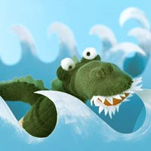](javascript:void(0))

What You Need:[close](javascript:void(0))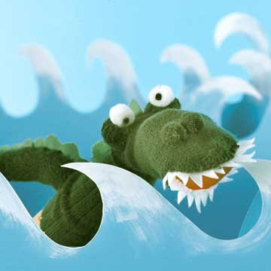

* Green socks
* Scissors
* Green felt

Instructions:

* 1. **To form the mouth,** cut along the toe seam of a green sock, and then sew a red felt oval to the opening and add teeth around the edges.
* 2. **Cut a tail, round eyes, and a nose** from the matching sock, stuff the pieces with batting, and stitch onto the puppet. Stitch a green felt zigzag strip down the gator's back and tail.

Try these fun experiments at home!

**Cold and hot**

Explain to your child that cold water is heavier than warm water. Fill a large bowl or aquarium halfway with warm water. Add red food colouring until the water is saturated with colour. Next, fill a jug with cool water and ice cubes. Stir the water until the ice melts, then add blue food colouring. Ask your child to guess what will happen when you add the cold water to the warm, and then slowly pour in the cold water. The blue water should sink and form a layer under the red water.

**Mixing**

Put out small bowls of materials such as flour, sugar, paint, sand and oil. Give your child a small bowl of water and ask him to choose a material to mix with his water. Encourage your child to first make a prediction about what will happen when he combines it with water. Give him plastic spoons or let him use his fingers to mix the two materials together. Discuss the results.

Useful Information

Welcome back! We hope you have had a relaxing and enjoyable Half Term. Please find some information below which we hope you will find useful.

Reading is taught throughout the week in our class and group lessons and specifically during Group Time Sessions. Additionally, individual reading books are changed on a **Monday** and a **Thursday** by the class teacher and TAs who may also listen to your child read.

Please ensure your child has their reading book, home school dairy and book bag in school EVERY DAY.

Thanks You

Yoga and PE lessons will be on a Tuesday and Wednesday:

Please ensure your child has their PE kit at school ready for use and that all clothing is clearly named.

Winter PE kit; blue shorts, white T-shirt, plimsolls or trainers.

Summer PE kit; blue shorts, white T-shirt, plimsolls or trainers.

Children can also wear tracksuit tops and bottoms.

|  |  |  |  |  |  |
| --- | --- | --- | --- | --- | --- |
| Tues 25th February  **Honeybees**  Yoga with Mrs Grimsdale | Tues 3rd March  **Caterpillars**  Yoga with Mrs Grimsdale | Tues 10th March  **Ladybirds**  Yoga with Mrs Grimsdale | Tues 17th March  **Honeybees**  Yoga with Mrs Grimsdale | Tues 24th March  **Caterpillars**  Yoga with Mrs Grimsdale | Tues 31st March  **Ladybirds**  Yoga with Mrs Grimsdale |
| Wed 26th February  **Caterpillars Ladybirds Honeybess**  PE with Premier Sports coach | Wed 4th March  **Caterpillars Ladybirds Honeybess**  PE with Premier Sports coach | Wed 11th March  **Caterpillars Ladybirds Honeybess**  PE with Premier Sports coach | Wed 18th March  **Caterpillars Ladybirds Honeybess**  PE with Premier Sports coach | Wed 25th March  **Caterpillars Ladybirds Honeybess**  PE with Premier Sports coach h | Wed 1st April  **Caterpillars Ladybirds Honeybess**  PE with Premier Sports coach |

The Foundation Stage Team

Useful Information

**Paediatric First Aiders In Foundation Stage**

Catherine Zucconi

**Managing Medicines**

Tracey Dale

**Allergens**

|  |  |  |  |  |  |
| --- | --- | --- | --- | --- | --- |
| **Mallable/creative** | **Containing Gluten** | **Sesame** | **Egg** | **Milk** | **Soya** |
| **Play dough** | **Wheat ✓** |  |  |  |  |
| **Pasta** | **Wheat ✓** |  |  |  |  |
| **Rice** | **Wheat ✓** |  |  |  |  |
| **Salt Dough** | **Wheat ✓** |  |  |  |  |
| **Cooking** | **Containing Gluten** | **Sesame** | **Egg** |  |  |
| **Pitta Bread Pizza –Wholemeal Pitta, Cheese Tomato Passata, Sweetcorn, Mushrooms, Pineapple** | **Wheat ✓** |  |  | **✓** |  |
| **Chocolate Easter Nests: Milk Chocolate Cake Covering Cornflakes Margarine Golden Syrup** | **Barley ✓** |  |  | **✓**  **✓** | **✓** |