Questions This Week:

What can we find beyond the sky? What’s in Space? How will we get there? WB: 13.1.19

We will be looking at information books about Space, Stars and Planets.  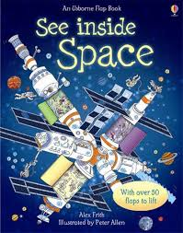 | We will be reading stories.  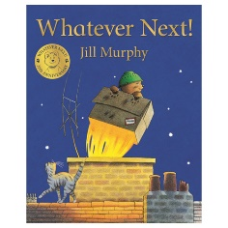 | We will be going to the Moon and thinking about what we might see? We will use our sounds to help us write about our trip.  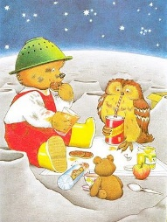
We will learning about different ways of joining paper using a stapler and by making tabs.  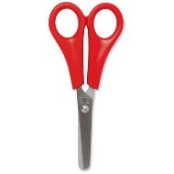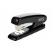 | We will be learning about number 6 and ways we can represent the number through actions, mark making and counting.  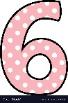 | In computing we will be creating pictures of rockets, using the different paint tools on the Purple Mash software.  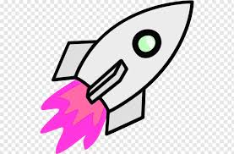
We will be creating Space pictures. We will be reflecting and seeing what we can do to make them even better.  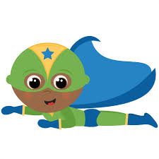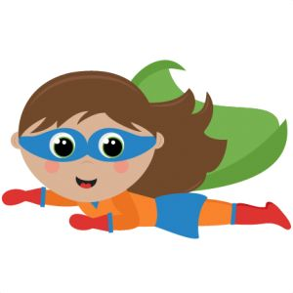 | We have been telling our own stories about space or whatever we choose to.  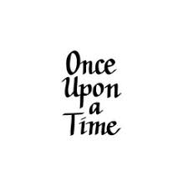 | We are writing for a range of purposes. The adults are reminding us to write a label for a model or instructions of how to make it.  