Questions This Week:
Which planet do we live on? What makes Earth special? What are stars? Which star is the most important for our planet? WB:14.1.19

We will be looking at information books about Space, Stars and Planets.  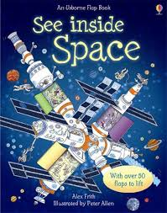 | We will be reading stories.  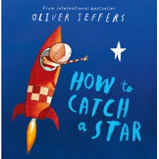 | We are trying to write the frequency words that we sent home.  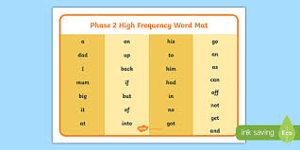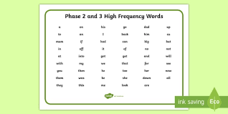
Every day we think of a new number and learn all about it.

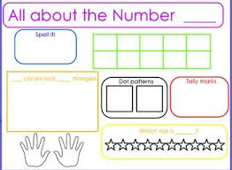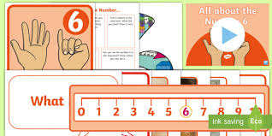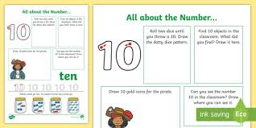

Last week, we created rockets and space pictures. We will be reflecting and seeing what we can do to make them even better.  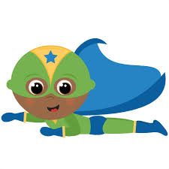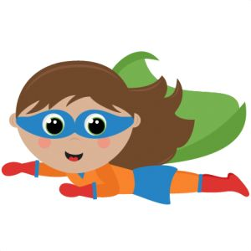 | We have been telling our own stories about space or whatever we choose to.  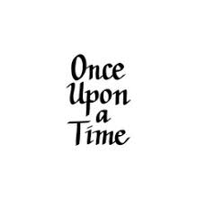 | We are writing for a range of purposes. The adults are reminding us to write a label for a model or instructions of how to make it.  