Autumn Term 1: All About Me Week beginning **9th October 2017**

Question of the Week:

What parts of the body are important for exploring our sense of smell and taste?

In **Topic** we are learning:

About our senses and what they are used for.

 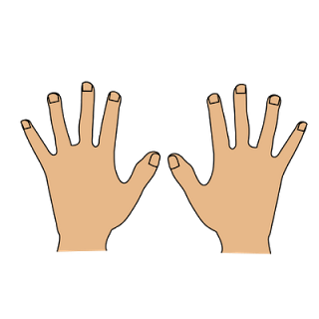  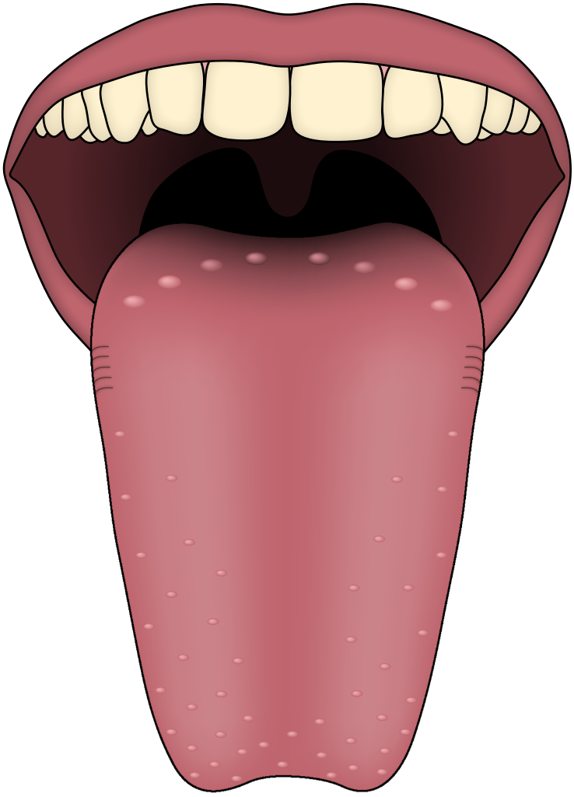

**FS Maths Workshop**

Wednesday 2.45pm in the classrooms. All parents are invited to come and play some Maths games in their child’s class.

In **Mathematics** we are learning to:

* Count forwards and backwards to 20
* Recognise what a given number looks like
* Apply our counting skills to dice games

In **Phonics** we are:

Learning to recognise, say and write the sounds;

i n m d

Practising oral blending and segmenting.

In **Literacy** we are:

* Practicing drawing and writing initial sounds.
* Practising **i,n,m,d** letter formation.
* Stories about Healthy Foods.

This week’s school value: **Belonging**

**PE** is every Wednesday!