GOVERNOR FACT FILE
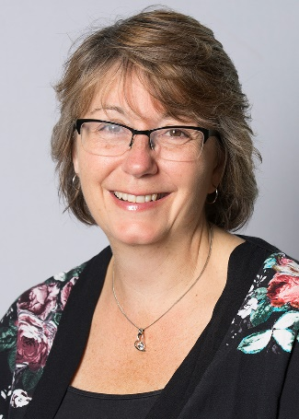
Name | Michelle Russell
Type of Governor | Co-opted Governor
Specific Governor Role/s | Early Years Governor
When did you join the Governing Body | June 2015
Committees you sit on | Personnel, Teaching & Learning
Favourite subject when you were at school | English
Favourite Food | Roast
Favourite Colour | Blue
Favourite Children’s Author | Enid Blyton
Favourite Children’s Film | Cinderella
Hobbies | Cooking, Walking
Your role model | My Dad
Your ambition when you were a child | To be a secretary!!!
Favourite thing about being a governor | Involvement in the school my children attended. Supporting EYFS giving best opportunities for all children

