HEALTH WEEK – YEAR TWO
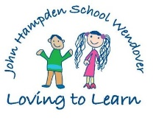
Monday 16th October | We may use ‘Purple Mash’ on the computers to complete activities linked to Health Week. | We will complete a P.E. session with a Premier Sport Coach. | We will work with A-Life to complete some Healthy Eating activities  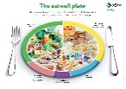 | At other times during the week, also linked to Health Week, we will complete:  - Relaxation techniques  - Circle Times  - P4C sessions  - Target setting  - Mindfulness activities  - Healthy Eating activities  - Problem solving activities
Tuesday 17th October | We will meet Doctor Evans who will teach us how to keep well. | We will have a Fun Fitness session with A-Life | We may use ‘Purple Mash’ on the computers to complete activities linked to Health Week.
Wednesday 18th October | We will learn about the 3 C’s -  Courage, Curiosity and Creativity with Everyball | We will complete a yoga session with Mrs Grimsdell
Thursday 19th October | We might join in with a Bike It Breakfast if we cycle to school.  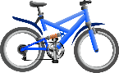 | We will complete a Zumba Workout with Mrs Nelson.  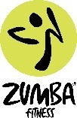 | We will make a Fruity Pick & Mix with Mrs Spencer | We will have a ‘Passport to Fitness, walk or scoot to School’ Assembly with time for questions.  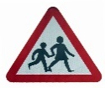
Friday 20th October | We will learn about Dental Health with Ms Ives

