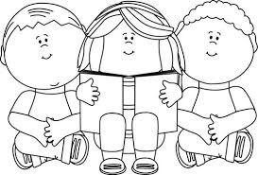 Book Review By Ali Year 2 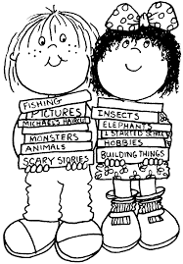
Title:
Diary of A Killer Cat by Anne Fine

Did I enjoy the book?
What a great book that was! I loved the story. I also loved the sarcasm in it as well. The detail of it was great and I loved the story language. How Tuffy lies and explains that he didn’t do it makes me laugh and how Dad describes Tuffy also makes me laugh.

What as my favourite part?
I really enjoyed the whole book, but if I was to choose a favourite part I would choose when the family pretended and acted that they didn’t know that Thumper died and said things like, “Oh no” and “Poor Thumper”.

Who is my favourite character?
That is an easy question because it is very simple that it is Tuffy. I adore Tufffy because every second that Tuffy speaks it makes me think that if I were an author when I grow up, I would be an author just like that.

How did I feel about the book?
I felt very excited from Friday because it said that they nailed up the cat flap, it left a real excitement of what was going to happen on Saturday.

Who would I recommend this book to?
I would recommend this book to my sister because she is always talking to her friends on the laptop, so she can read for a while and forget about talking to her friends.

Character Description

Tuffy

Tuffy is a stripy, mischievous cat who always kills animals and brings them into the house. He has killed a cute, poor bird and a tiny miserable, mousy thingy. When the owners tell him to do something he disobeys them, or he sometimes ignores the owners.

Tuffy has pointy ears that hear perfectly well and he sniffs mysterious things that we can’t smell. He is covered from head to toe in ginger stripes and has claws as sharp as knives and daggers. Tuffy has a mischievous face on him all day because he is always making cunning plans. He has eyes that can see everything around home, so keep an eye on him all day because he is always making cunning plans. He has eyes that can see everything around him, so keep an eye on him, so he is not going to trip you up, or something else.

It is very hard to describe Tuffy’s behaviour because he is always in trouble! Tuffy is a cat who creeps around quietly and then strikes – but not like any other cat because when he strikes he doesn’t jump, he pounces and traps it into his paws.

I would definitely like to be Tuffy’s friend, if he is up to mischief or not.

