SAFETY WEEK – FOUNDATION STAGE

Monday 30th October | We will have a safety talk from a police officer | We will meet Mr Nelson – a paramedic |  | At other times during the week, also linked to Safety Week, we will learn about:  - How to enjoy Halloween safely  - Medicine safety  - Stranger Danger  - Risk and Danger  - What would happen if…  - Resilience  - Safety through P4C
Tuesday 31st October | We will learn how to cross the road safely with Junior Road Safety Officers from Wendover Junior School  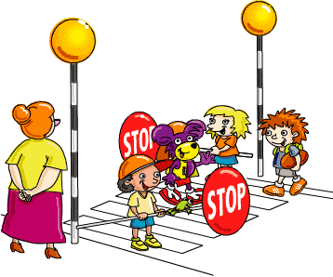 | We will meet Mrs West, the School Crossing Patroller, who will talk to us about Road Safety | We will learn about water safety 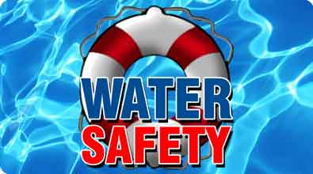
Wednesday 1st November | We will have an anti-bullying assembly with Mrs Barnes | We will learn about safety around dogs in an assembly | We will learn about e-safety with Mrs Shrimpton
Thursday 2nd November | We will learn about keeping medicines safe
Friday 3rd November | We will learn about Firework Safety | We will learn about Fire Safety | We will have a ‘Taking Care of Myself’ assembly

