The John Hampden School Wendover

Annual Pupil Premium Report to Governors for Academic Year 2016-2017
The Pupil Premium is an element of school funding aimed at diminishing the difference in attainment of certain disadvantaged groups of pupils. It is calculated based on the number of children receiving free school meals, the number of ‘Looked After Children’ and the number of children from Service families. The Premium can be spent how the school decides and must ensure that standards are raised as a result of the spending,
The Ofsted inspection framework will have a particular emphasis on how well differences are diminishing both within the school and in comparison to national trends with specific reference to children eligible for the Pupil Premium.
In April 2017, for the financial year 2017-2018, our budget share allocated a total Pupil and Service Premium amount of £29,500 (approx. 2% of our overall revenue budget). Page 2 is a summary of the way we have used this funding to support our pupils’ learning.
(Note: Information related to individual pupils remains confidential)
PUPIL PREMIUM FSM
Number of children eligible in January 2017 census: 15
Budget Allocation April 2017 = £19,800
This category includes any child that has been registered for FSM in the past 6 years (‘Ever 6 FSM’)
£1,320 per child eligible for FSM and per child identified as ‘Ever 6 FSM’
PUPIL PREMIUM SERVICE CHILDREN
Number of children eligible January 2017 census: 26
Budget Allocation April 2017 = £7,800
£300 per child of a service family
PUPIL PREMIUM PLUS LAC
Number of children eligible January 2017 census: 1
Budget Allocation April 2017 = 1
£1,900 per child
TOTAL Pupil Premium Grant allocation 2017-2018 = £29,500
Principles:
- We ensure that teaching and learning opportunities meet the needs of all pupils.
- We ensure that appropriate provision is made for pupils who belong to vulnerable groups, this includes ensuring that the needs of socially disadvantaged pupils are adequately assessed and addressed.
- In making provision for socially disadvantaged pupils, we recognise that not all pupils who are eligible for free school meals will be socially disadvantaged.
- We also recognise that not all pupils who are socially disadvantaged are registered or qualify for free school meals. We reserve the right to allocate the Pupil Premium funding to support any pupil the school has legitimately identified as being socially disadvantaged.
- Limited funding and resources means that not all children eligible for free school meals will be in receipt of pupil premium interventions at all times.
- Provision will not be aimed at teaching and learning for pupils with an EHC Plan as funding for need is already in place.
- It will be the responsibility of the Headteacher and the SCNC (Service Children Nurture Co-ordinator) to produce regular reports for the Governing Body about the impact of Pupil Premium Funding.

Summary of Pupil Premium spending 2016/17
Objectives in spending :
FSM
- To diminish differences for those pupils not on track to make expected progress at the end of each year in Reading, Writing and Mathematics.
- To provide extra adult support to facilitate social and emotional development, 1-1 support and small group interventions alongside other children
- To deliver additional, personalised learning opportunities for individuals on their own or within groups including other children
SERVICE FAMILIES
- To enable families to keep in contact during deployment
- To enable additional opportunities for pupils to receive additional 1-1/ small group support on their own or within groups including other children
- To reinforce a point of contact for Service families on the campus
- To facilitate links between service families and families of other children
- To purchase specific resources for use by service children and other children
- To provide a stimulating and informative interactive display to raise awareness for all staff and pupils
- To provide all pupils with a focus and a point of reference
LAC
- To diminish differences for those pupils not on track to make expected progress at the end of each year in Reading, Writing and Mathematics.
- To provide extra adult support to facilitate social and emotional development, 1-1 support and small group interventions for those children – these groups will involve other non-LAC
- To deliver additional, personalised learning opportunities for individuals on their own or within groups of other non- LAC

Summary of Pupil Premium spending/actions Academic Year 2016/17
Item/project | Cost  2016/2017 | Objective | Outcomes/Impact to date
FSM  Extra-curricular activities  School Visits  Individual support dependant on need | £30 voluntary contributions x15  + extra-curricular activities e.g. clubs  £800  TA Time/SLT Time  £2000 | To deliver additional, personalised learning opportunities for individuals | Objective met: FSM children have been clearly identified and necessary support has been organised. Positive feedback from parents
FSM  Social and emotional support | LSA Time  £3500 | To provide extra adult support to facilitate social and emotional development, 1-1 support and small group interventions | Objective met: Nurture group set up for vulnerable pupils.  Social Skills group set up for vulnerable pupils
FSM  Learning Support | TA Time  £4500  LSA Time  £4500 | To narrow the gap for those pupils not on track to make expected progress at the end of each year in Reading, Writing and Mathematics. | Tracking information collected in Autumn, Spring and Summer Term.  Small numbers of FSM children and of these a significant proportion had SEN too.
FSM  Provision of School Uniform  Christmas Play Tickets | £2000 | To ensure parents are supported in providing children with appropriate clothing, equipment and support for school | Objective met: FSM children have been clearly identified and necessary financial support has been organised. Positive feedback from parents
LAC | TA Time  £1500  LSA Time  £2000 | To narrow the gap for those pupils not on track to make expected progress at the end of each year in Reading, Writing and Mathematics. | Tracking information collected in Autumn, Spring and Summer Term.  With additional support children were making better than expected progress.
LAC  Social and emotional support | LSA Time  £900 | To provide extra adult support to facilitate social and emotional development, 1-1 support and small group interventions | Objective met: Nurture group set up for vulnerable pupils.  Social Skills group set up for vulnerable pupils
TOTAL | £21,700
Item/project | Cost  2016-2017 | Objective | Outcomes to date
SERVICE  Pupil Support | Service Children Support Co-ordinator  £7,500  Teacher co-ordinator time  £200 | To enable additional opportunities for pupils to receive additional 1-1/ small group support | Objective met: evidence in the form of weekly feedback from SCSN co-ordinator reflects that Service children feel supported and settled in school. There is a clear communication route for children and their parents.
SERVICE  Family Support  Teacher support | Refreshments  £50 | To establish a point of contact for Service families on the campus | Objective met: Coffee mornings arranged for parents of Service children, some more well attended than others!
SERVICE  Raise profile of Service children in the school | SCSN co-ordinator time  £100 | To provide a stimulating and informative interactive display to raise awareness for all staff and pupils | Objective met: creation of a positive school atmosphere in which pupils’ differences are recognised and valued/understood within the school community.  Staff have a greater awareness of service families
SERVICE  Raise profile of Service children in the school | SCSN co-ordinator time  £100 | To provide pupils with a focus and a point of reference  Red, White & Blue Day  Bear Mascots | Objective met: Service children have an accessible focus/source of support.  Anecdotal feedback reflects a greater understanding within the school  Red, White and Blue day assembly run by SCSN co-ordinator and Teacher
TOTAL | £7,950

Total Pupil Premium received | £29,500
Total Pupil Premium expenditure | £29,650
Pupil Premium remaining | -£150

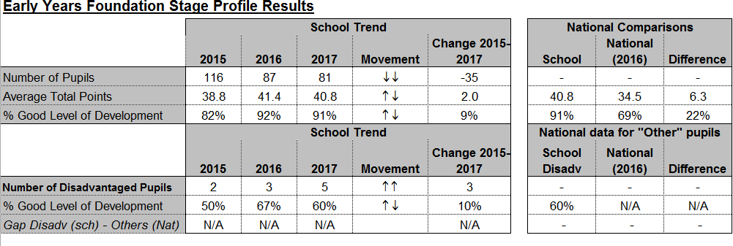
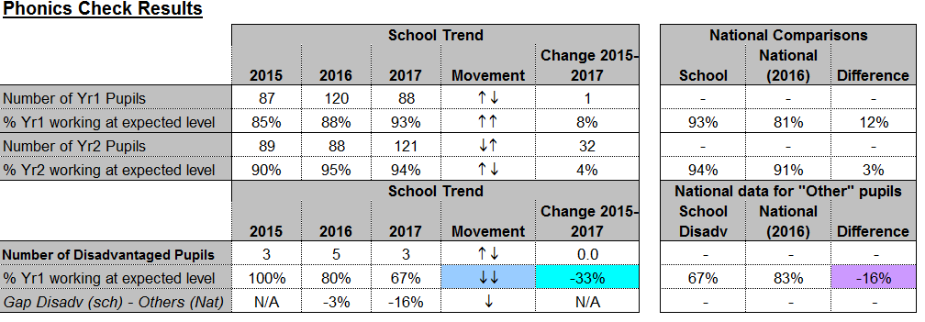
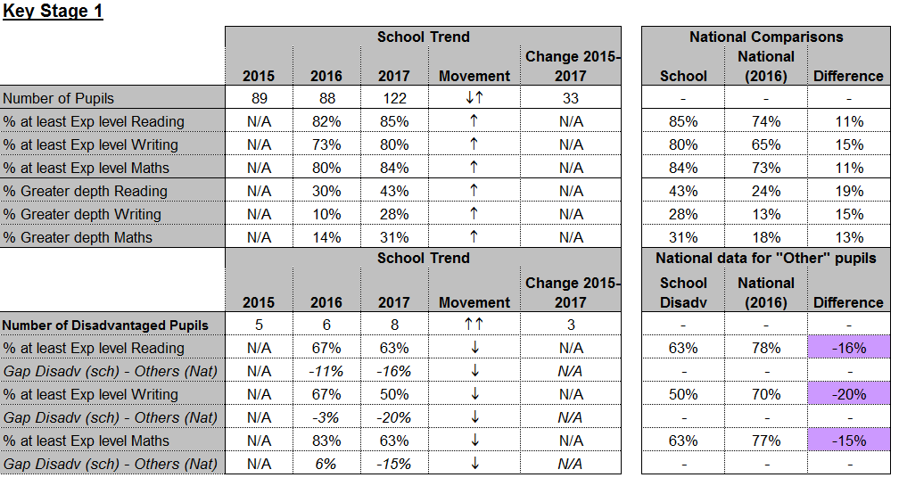

Academic Year 2017-2018

PUPIL PREMIUM FSM
Number of children eligible October 2017 census = 20
Budget Allocation April 2018 = tbc (estimate £26,000)
This category includes any child that has been registered for FSM in the past 6 years (‘Ever 6 FSM’)
£1,300 per child eligible for FSM and per child identified as ‘Ever 6 FSM’
PUPIL PREMIUM PLUS LAC
Number of children eligible October 2017 census =2
Budget Allocation April 2018 = tbc (estimate £3,800)
£1,900 per child
PUPIL PREMIUM SERVICE CHILDREN
Number of children eligible October 2017 census: 32
Budget Allocation April 2018 = tbc (estimate £9,600)
£300 per child of a service family

Summary of Plans for Pupil Premium spending Academic Year 2017/18
Main Barriers faced by eligible pupils:
- Absence of parent/carer during deployment
- Frequent relocation/moving schools
- Lack of learning support from home
- Lack of family community links
- Limited opportunities for extra-curricular activities, activities outside school
- Option of uniform with school logo not chosen
- Requirement for nurture support

Planned spending objectives :
FSM
- To narrow the gap for those pupils not on track to make expected progress at the end of each year in Reading, Writing and Mathematics.
- To provide extra adult support to facilitate social and emotional development, 1-1 support and small group interventions for those children.
- To deliver additional, personalised learning opportunities for individuals
- To provide additional extra-curricular opportunities if required
LAC
- To narrow the gap for those pupils not on track to make expected progress at the end of each year in Reading, Writing and Mathematics.
- To provide extra adult support to facilitate social and emotional development, 1-1 support and small group interventions for those children.
- To deliver additional, personalised learning opportunities for individuals
- To provide additional extra-curricular opportunities if required

SERVICE FAMILIES
- Continue to employ Nurture/Support co-ordinator
- To accurately track changes in circumstances by developing appropriate methods of recording and sharing information
- To provide support and nurture for eligible pupils and their families
- To liaise with relevant agencies to share knowledge and expertise
These objectives have been chosen as they allow us to address the identified barriers faced by eligible pupils. The barriers and the associated objectives are reviewed annually but may be amended to meet the needs of any eligible pupil.

Sue Barnes January 2018

Next review of Pupil Premium Strategy: January 2019

