Year 1


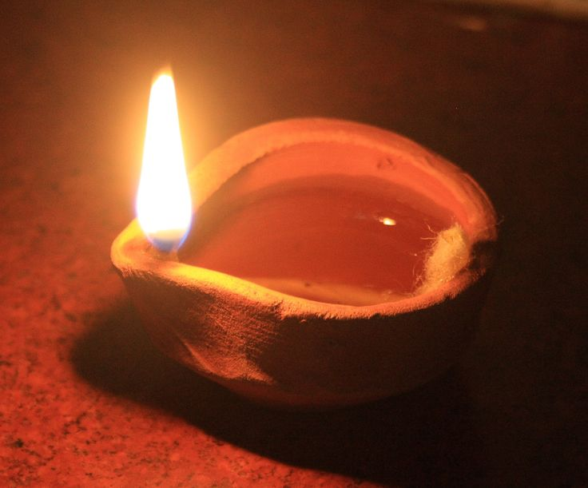



Autumn Term 2
2017

YEAR 1 Useful Information
All of the children have continued to settle well into the school routines in Year One. Please find some information below that we hope will give you an insight into some of the work that your child will be doing this half term.
English/Topic
Our topic this half term is “Let’s Celebrate!” through which the children will develop a variety of skills in different areas of the curriculum.
Work in English will centre on the children listening to, following and writing instructions, with a focus on drafting and improving their work. We will start by working practically to follow instructions, therefore developing their understanding of imperative (bossy) verbs. The children will then have the opportunity to use their knowledge to write their own instructions. We will continue to work on simple elements of punctuation and the children will learn a range of nouns and verbs. We will also continue to focus on developing handwriting skills and careful presentation of their work.

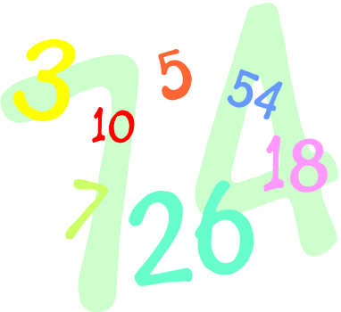
Maths
Maths lessons will focus on addition, subtraction and difference with the support of counting equipment, a number line and a 100 square. There will be a particular focus on accurate number writing as well as continued work on place value of numbers. We will also be focussing on 2D shape and their properties.

Science & Geography
During Science sessions we will learn about seasonal change, the children will observe changes as we move from Autumn into Winter. We will record our observations in a range of ways including charts and simple diagrams. In Geography, we will look at the weather in the UK and we will talk about shortened day time hours. The children will produce a simple weather diary.

RE
We have started to learn about different religious festivals that share the theme of light, these include; Hanukah & Christmas. We will read stories related to Rama & Sita as well as Babushka.
P4C
We have already starting discussions based on key questions. We will learn the terms ‘agree’ and ‘disagree’ and will learn to support our point of view with a reason.
PSHE
We will talk about our school values for this half term – perseverance, collaboration and reflection and will role-play different scenarios. The children have already started to learn more about friendship; getting along and what to do when we fall out with someone.
Computing
The children will focus on logging on, entering a password and logging off a computer. They will be taught simple typing and programming skills and will create a Christmas card through a series of lessons during computing sessions.
Music
Mrs Collins will continue to lead music sessions this half term where the children will learn Christmas songs and further develop their understanding of rhythm using percussion instruments.
Art
Art lessons will enable the children to develop their experience of different painting techniques and textures.
Design and Technology
In D&T the children will design and make a moving picture linked to Christmas.


Phonics
This will continue to be taught daily in Year One and will be referred to throughout all lessons. During these sessions, children are taught to blend to read and to segment to spell. We expect the high frequency words to always be spelt correctly in their written work, including homework.
Phonic sheets will be sent home for the children to practise each week. They will have different sounds to learn and words to blend and read.
Tricky & High Frequency Words
Following our assessment of Tricky & High Frequency words for reading & spelling, we will continue to practise them at school and ask that children continue to practise them at home too. Children should have instant recall of these words and should not be blending them. Your support with this would be much appreciated.


Home/School Diary
We would like you to continue to complete the Home/School Diary on a daily basis. Please ensure you initial the book when you have heard your child read as they will only be able to change their reading books on Mondays and Thursdays if the books have been completed, and signed by you. Please can you help your child to fill in the “smiley faces” daily as this gives us a strong indication of how they feel about their time in school and we can discuss any issues/concerns with them. Teachers will collect the diaries in each week to sign them. If you have written any notes for us in the communication box please ensure your child shows them to the class teacher/teaching assistant on entry.
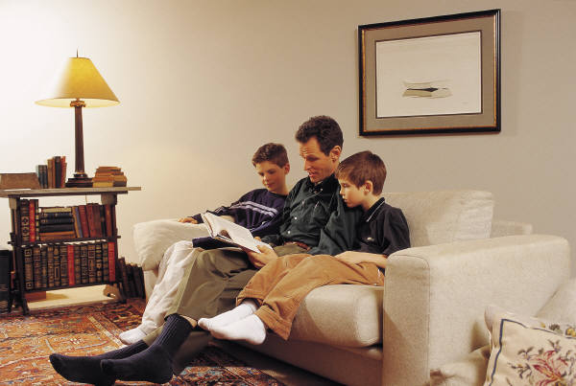
Homework
We have been pleased to see the work already completed by your children in their homework books. The work is designed to take about 20 minutes to complete (but if your child is particularly enthusiastic do not take this as a hard and fast rule!) The books will be given out on alternate Fridays, and should be returned to school by a week the following Wednesday. Please do come and talk to the teacher or teaching assistant if there is a concern with homework. We would encourage you to support your child with their homework as necessary, but would love all recorded work to be their own. Just a reminder that the “discussion” element of the homework does not need to be recorded.

PE

Each week the Squirrels, Badgers and Hedgehogs classes will continue to have a PE lesson led by a Sport’s Coach. Other PE lessons are on Thursdays. This term, the children will be learning further skills in dance in readiness for the Christmas performances. They will be practicing a range of other PE skills too. Please ensure that your child has an appropriate PE kit for sessions inside and outside – ALL NAMED, this should include jogging bottoms or leggings. Also, please check regularly that their plimsolls or trainers fit properly. Children with long hair should have it tied back on PE days and any children with earrings should come to school with them removed on PE days or should have their own tape to cover earrings themselves before the PE lesson.

Events
The children thoroughly enjoyed safety week and asked our visitors lots of interesting questions. They took part in a range of exciting activities to reinforce important messages.
It is good to see so many children coming into school independently ready to start their school day. They are already carrying out a number of activities by themselves.
As Autumn is now upon us, please ensure that your child comes appropriately dressed with named coats, scarves, hats and gloves. The children do spend time outside on a daily basis.
Thank you for your continued support and co-operation.
Yours sincerely
Year One team
Possible Activities To Do:
Listed below are some general ideas for activities you can do at home with your child to support their learning. Please encourage your child to bring into school any activities they complete to share with the class.
- Practise the names of the different seasons, days of the week and months of the year.
- Choose a tree you see or pass regularly and note the changes it goes through over the coming weeks.
- Talk about animals that hibernate over winter.
- Keep a weather diary for a week or more, notice any weather patterns.
- Look up sunrise and sunset times for each day in a week, make comparisons with those in the summer.
- Visit different places of worship; look at different features and patterns.
- Read stories & poems that have the theme of ‘light’.
- Find out information about different sources of light using information books from the library or the internet.
Useful websites
- http://www.bbc.co.uk/schools/parents/resources/ select the 4-7 age range and the area you are interested in (e.g. Maths, science etc.). This brings up a list of relevant activities/games you can choose from depending on your child’s interests.
- http://www.woodlandtrust.org.uk a wide variety of ideas for activities to do with your children to help them explore their local area and widen their knowledge of the natural environment.
- www.sciencekids.com
- www.bbc.co.uk.dancemattyping to practise keyboard typing skills which will support our learning in school.
Places to visit
St Tiggywinkles, Tring Museum, College Lake, Tring, Wendover Woods, The Science Museum

