Year One

Spring Term 1
2018

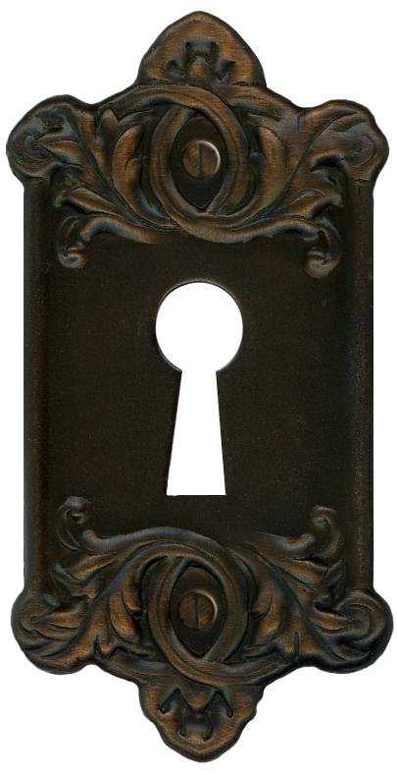
Through the keyhole

YEAR 1 Useful Information
The children have settled back quickly into the school routines after the Christmas break. Please find some information below that we hope will give you an insight into some of the work that your child will be covering this half term.

English/Topic
The topic is “Through The Keyhole”. The children had the opportunity to begin the work linked to recounts by sharing their Christmas holiday experience. We will be developing their understanding of recounts by using the book ‘You Choose’. The topic will also link to our science lessons (see below for further details) and Art sessions. We will also continue to focus on variations in seasons and the weather.
Work in Literacy will include sentence writing and descriptions with a particular focus on grammar, punctuation and presentation.

Maths
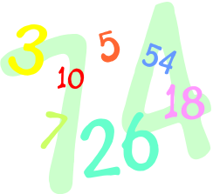
Maths lessons will focus on further developing skills in number including addition, using a number line and a 100 square. We will also concentrate on writing numbers as words and solving one step problems. There will also be a series of lessons focusing on number bonds.
The children will also have the opportunity to explore Maths in greater detail during our Maths Day, which is coming soon.

Science
Science lessons will enable the children to make further observations about seasonal change and they will record their findings in different ways. They will develop understanding of different materials, their properties and possible uses, with a particular emphasis on materials used in homes. We will perform simple experiments to test different materials. Art will also be linked to the materials topic.

RE - The focus is on special things and the children will be exploring the following questions; what things are special in your home, to you and to your family and friends. We will also look at how the new year is celebrated in different cultures and countries.
P4C - Stories, music, videos, pictures and objects will be used as a stimulus for philosophical discussions. Children will be encouraged to think of questions to discuss. They will develop skills in giving reasons for a point of view and we will move on to looking at the difference between an open and closed question. ‘Thinking day’, coming soon, will also give the children the opportunity to develop their thinking, questioning and reasoning skills.
PSHE
We will talk about our school values for this half term – independence, perseverance, good manners and reflection. We will be setting ourselves individual and class goals for the New Year and look at ways to help us to achieve them.

Computing
The children will be taught painting and programming skills and will create a piece of electronic artwork. We will continue to focus on familiarisation of the keyboard and we will highlight the importance of using the web safely. We will also continue to focus on further developing typing skills.
Music
We will focus on rhythm and sound patterns using percussion instruments, the children will also learn a range of songs.
Art
The children will use a variety of materials to create a collage.


Phonics
This will continue to be taught daily in Year One and will be referred to throughout all lessons. During these sessions, children are taught to blend to read and to segment to spell. Please continue to practise the blending sheets that your child brings home each week.
Tricky & High Frequency Words
The children will continue to have the opportunity to practise spelling High Frequency words and Tricky words each week in Literacy lessons. We ask that children continue to practise them at home too. Children should have instant recall of these words and should not be blending them. Your support with this would be much appreciated.
Spellings
Spellings for the week are on the back of the blending sheet. The spelling test will take place every Friday, please practise them with your child frequently, we will continue to go over them at school too. Our phonics focus for the week links to the spellings that the children practise at home.


Home/School Diary
Please ensure you initial the book when you have heard your child read as they will only be able to change their reading books on Mondays and Thursdays if the books have been completed, and signed by you. Please can you help your child to fill in the “smiley faces” daily as this gives us a strong indication of how they feel about their time in school and we can discuss any issues/concerns with them. Teachers will collect the diaries in each week to sign them. If you have written any notes for us in the communication box please ensure your child shows them to the class teacher/teaching assistant on entry.
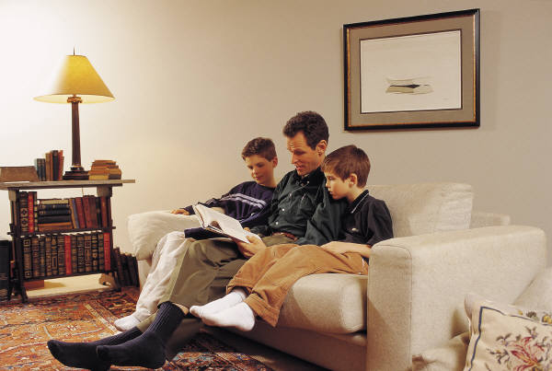
Homework
We have been pleased to see the work already completed by your children in their homework books. The work is designed to take about 20 minutes to complete (but if your child is particularly enthusiastic do not take this as a hard and fast rule!) The books will be given out on alternate Fridays, and should be returned to school by a week the following Wednesday. Please do come and talk to the teacher or teaching assistant if there is a concern with homework. We would encourage you to support your child with their homework as necessary, but would love all recorded work to be their own. Just a reminder that the “discussion” element of the homework does not need to be recorded.
Please ensure your child uses a pencil to record any writing and any high frequency words should be spelt correctly. We would also like your child to consider the presentation of their work as this is a focus for all their work books in school.

PE

On a Tuesday, Squirrels, Badgers and Hedgehogs will continue to have lessons taught by a Sport’s Coach. PE lessons are on Thursdays. During the Spring term, the children will be competing the unit on Gymnastics and practicing a range of other PE skills inside and out. They will be practicing a range of other PE skills too. Please ensure that your child has an appropriate PE kit for sessions inside and outside – ALL NAMED, this should include jogging bottoms or leggings. Also, please check regularly that their plimsolls or trainers fit properly. Children with long hair should have it tied back on PE days and any children with earrings should come to school with them removed on PE days or should have their own tape to cover earrings themselves before the PE lesson.

We are pleased to see that most children are coming into their classrooms independently ready to start their school day and that they are able to follow the daily routines, such as independent book changing and on entry activities. Please continue to encourage this as it is so important to develop the children’s independence to enable them to be organised during their busy days at school.
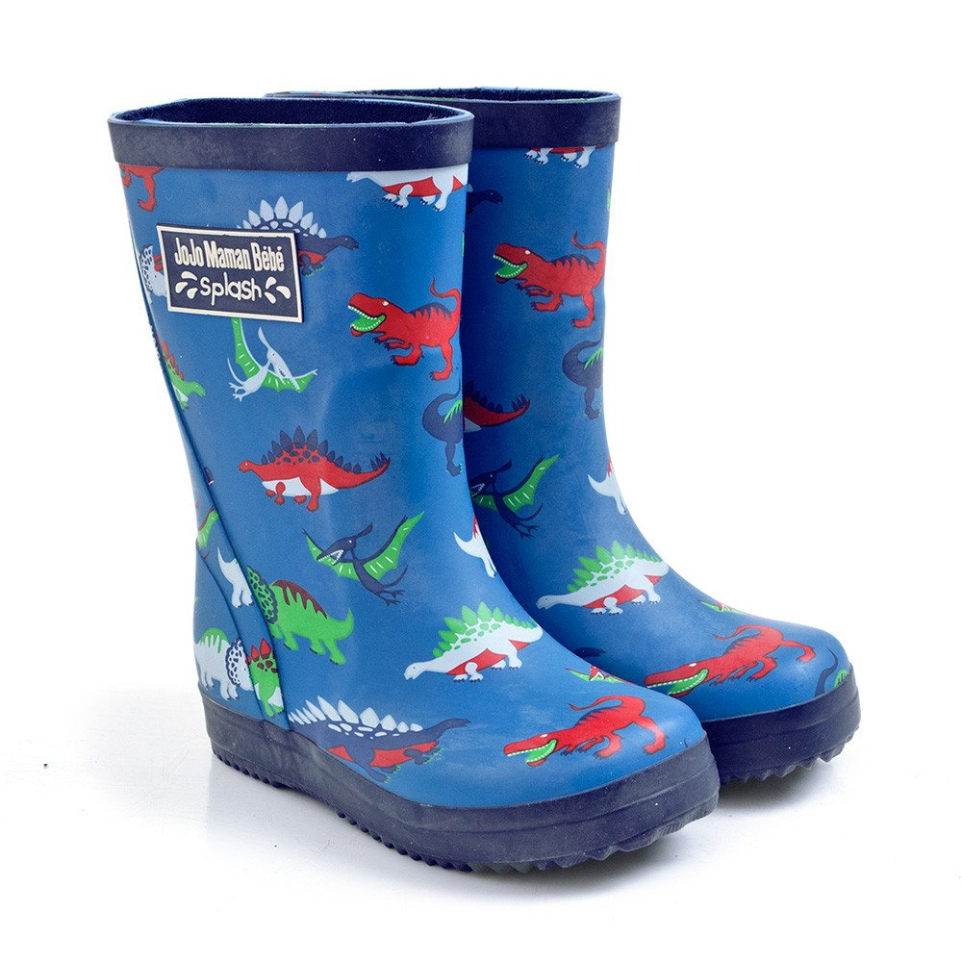
As the weather continues to be cold and wet please ensure your child comes appropriately dressed with named coats, gloves, hats etc. The children do spend time outside on a daily basis. Unfortunately, as there is a lot of building work taking place at the moment around the school and the playground can be muddy. The builders regularly jet wash the playground but it can still be quite messy, especially when the weather is wet. We are happy for your child to bring in a pair of (named) wellies to wear in the playground if you wish to combat the issue of muddy shoes.
Please do not hesitate to speak to members of the team if you have any concerns or questions, we are all here to help.
Thank you for your continued support and co-operation.
Yours sincerely
The Year 1 Team

Possible Activities To:
Listed below are some general ideas for activities you can do at home with your child to support their learning. Please encourage your child to bring into school any activities they complete to share with the class.
- Practise writing numbers as words.
- Practise high frequency and tricky words, play games with the words to help your child learn them (see the class teacher for further ideas if needed).
- Read a range of stories and talk about different characters and settings, also encourage retelling of the stories.
- Look at materials in your home and whilst out and about, identifying what things are made of and why a particular material might be used rather than any other.
- Encourage your child to look at buildings and see if they can work out, using the clues they know, whether the building is “old” or “newer”.
- Visit the BBC Schools website and encourage your child to use the Dance Mat Typing programme, to enable them to gain greater familiarity with the position of letters on the keyboard.
- Play games such as Ludo, Snakes and Ladders, Dominoes etc which involve completing mental calculations to work out the moves or score.
- Use packs of playing cards to play find the pair of numbers that make 10 etc.
Useful websites
- http://www.bbc.co.uk/schools/parents/resources/ select the 4-7 age range and the area you are interested in (e.g. Maths, science etc.). This brings up a list of relevant activities/games you can choose from depending on your child’s interests.
- http://www.woodlandtrust.org.uk a wide variety of ideas for activities to do with your children to help them explore their local area and widen their knowledge of the natural environment.
- www.sciencekids.com
- www.bbc.co.uk.dancemattyping to practise keyboard typing skills which will support our learning in school.
- www.tate.org.uk to view different paintings and see a listing of what’s on.
- www.nationalgallery.org.uk to view different paintings and see a listing of what’s on.
Places to visit
The Museum of London to investigate homes through the centuries in London.
Aylesbury Museum to look at building materials and paintings of dwellings in the past.
Warwick, Windsor or Berkhamsted Castle.
The Victoria & Albert Museum, London.
Art galleries.

