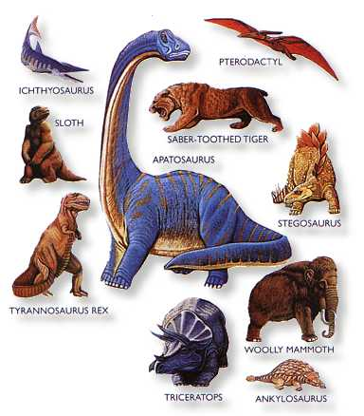
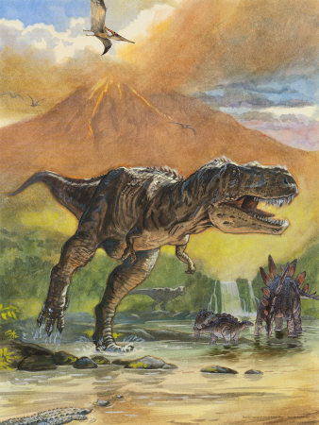
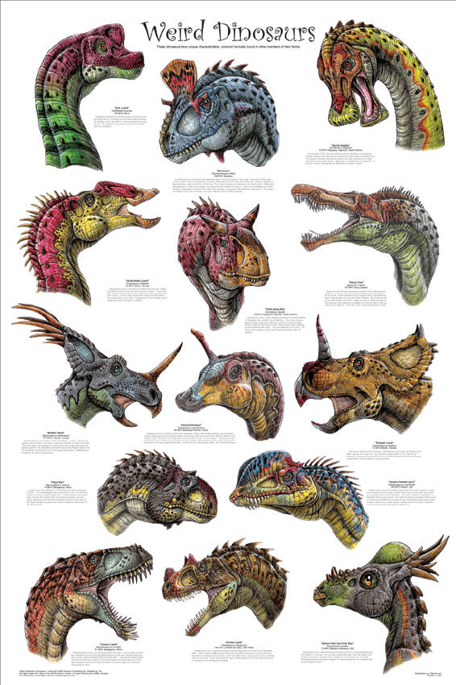

Foundation Stage
Topic Guide

Spring – Dinosaur Rumpus!

The children this term have decided that they would like to be Explorers! First of all they would like to learn about Dinosaurs, so the topic in Foundation Stage for the next few weeks is ‘Dinosaur Rumpus!’ To begin our topic we will be thinking about how we know that dinosaurs existed; examining fossils and exploring the role of palaeontologists. We will create a ‘Dinosaur Lookout’ role-play area to engage the children in the topic as well as developing mathematical skills, such as data handling and measuring. The children will be sorting and comparing different dinosaurs, and comparing dinosaurs to a modern day animal, e.g. woolly mammoths and elephants, looking for similarities and differences. We will be thinking about different environments and the habitats in which the dinosaurs may have lived, e.g. wet and dry.

This will be a fabulous topic for developing talk for writing skills to help children to become familiar with the patterns of stories. We will work on developing these skills to enable the children to become confident at having a go at their own story writing. The strategy behind talk for writing is ‘Hear it, say it, write it!’ We will be sharing lots of stories, talking them through with story maps and doing some shared writing to help with this process.

Through art the children will explore different textures and make models of dinosaurs and will use ICT programmes to share their images of dinosaurs. They will listen to different songs and music and create dances based around dinosaurs and big movements, e.g. stomping and stamping.

Our key author this half term is Ian Whybrow so please look out for his books at the library and share some of them together at home.

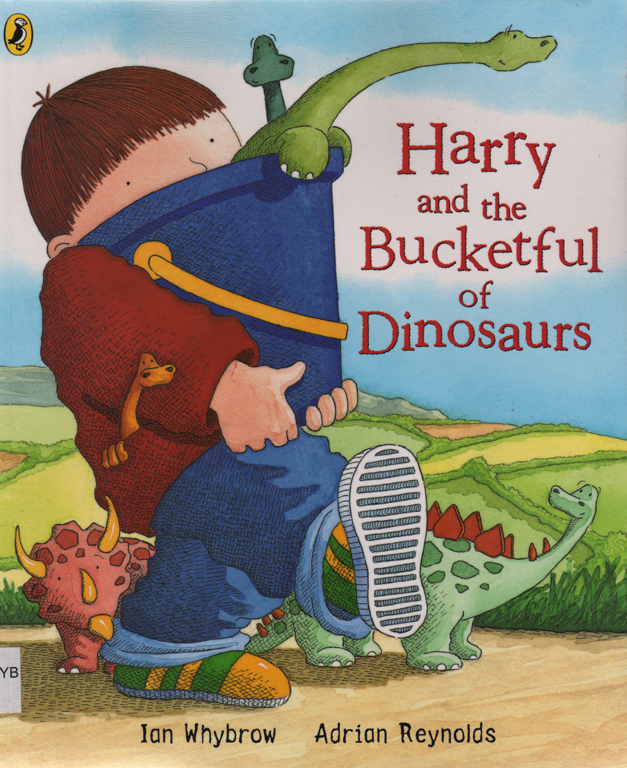
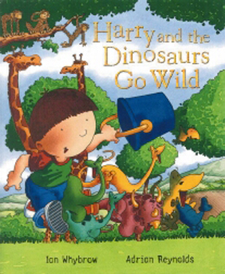

Places to Visit

Natural History Museum, Cromwell Road, South Kensington, London
http://www.nhm.ac.uk/
Tring Natural History Museum, Akeman St, Tring, Hertfordshire, HP23 6AP
http://www.nhm.ac.uk/tring/visiting/index.html

The Oxford Museum, Fletcher’s House, Park Street, Woodstock, OX20 1SN
https://wwww.oxfordshire.gov.uk/cms/content/oxfordhsire-museum-galleries
Oxford University Museum of Natural History, Parks Road, Oxford, OX1 3PW
http://www.oum.ox.ac.uk/index.htm
Please let us know if you discover any other worthwhile places to visit!
Useful websites:
http://www.ianwhybrow.com/about/
http://www.nhm.ac.uk/
http://www.nhm.ac.uk/kids-only/
http://www.tring.gov.uk/info/zoomus.htm
http://www.show.me.uk/topicpage/parents/pDinosaurs.html
http://www.dltk-kids.com/animals/dinosaurs.htm
http://www.enchantedlearning.com/subjects/dinosaurs/
http://www.kidsdinos.com/dinosaur-games/index.php

Activities for Parents and Children to share at home

The activities listed below are suggestions for things you might like to try with your child at home. The activities will complement the work we are doing in class. It is not expected that everyone will try all of the activities.

- Make dinosaur footprints in ‘plaster of paris’ using your toy models.
- Can you learn the full name of your favourite dinosaur?
- Paint or draw a picture of your favourite dinosaur.
- Make a dinosaur model from playdough.
- Can you make up a dinosaur story to tell?
- Excavate your own ‘dinosaur fossil’ from some mud or in the garden.
- Research about the different dinosaurs and create a fact file about them to share.
- Wash thoroughly some cracked eggs, then paint to decorate as dinosaur eggs. Perhaps your favourite dinosaur could hatch out!
- Dinosaur feet; give your child some large paper bags and have them colour or decorate the paper bag to resemble the way they think their favourite dinosaurs feet would look like. The child then wears the paper bag on their feet and dances to some suitably ‘dinosaury’ music and do a dinosaur dance.
- Dinosaur maths; can you measure out how long a dinosaur would have been? Use one small step for each equivalent foot length of the dinosaur.
Tyrannnosaurus Rex- 45 feet
Triceratops- 30 feet
Brachiosaurus- 90 feet
Apatosaurus- 70 feet
Stegosaurus- 20 feet

Make a ‘fossil’.

Materials
Clay or dough, items to imprint - leaves, coins, bugs.
Optional - shoe polish and varnish to finish
- Make a rock or plaque shape from the clay or use the dough recipe below.
- Create a smooth surface on the top side of your rock. (use water or just flatten the top on a counter or plate).
- Make imprints with different objects. Try leaves, coins, shells, or even a small toy. Make a foot that you can use to leave footprints.
- When it dries, rub on a bit shoe polish and varnish to make it last for months and months.
- Bury them in sand or dirt and have an expedition to dig up fossils like a palaeontologist.

Dough Recipe
(1 cup flour, 1/2 cup salt, 1 cup water, 1 tbsp oil, 2 tsp cream of tartar)
- Mix all ingredients in a pot and stir over medium heat.
- Mixture will be soupy with lumps. Suddenly it will form into a ball.
- Remove from heat, and knead on a non-stick surface.
- Useful for many types of projects.
- Store in fridge, or allow creations to air dry.
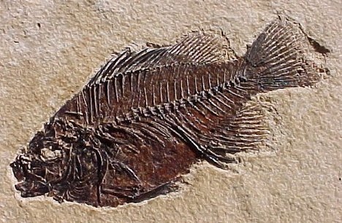

We asked the children what they wanted to learn about Dinosaurs.

Honeybees would like to find out…
- Do all dinosaurs have bones?
- How big were dinosaur’s feet?
- How dangerous were dinosaurs?
- What do dinosaurs eat?

Ladybirds would like to find out…
- Are all dinosaurs the same?
- What are fossils?
- Why do dinosaurs have sharp teeth?
- What do dinosaurs look like on the inside?

Caterpillars would like to find out…
- What do dinosaurs eat?
- What is the biggest dinosaur?
- How do dinosaurs get their prey?
- What is a volcano?

Paediatric First Aiders In Foundation Stage
Catherine Zucconi
Joe Beattie
Tracy Kernan

Managing Medicine
Tracey Dale

Allergens
Malleable | Containing gluten | Sesame
Play dough flour | Wheat 
Pasta | Wheat
Rice | Wheat
Cooking
Pitta bread rockets  Houmous, carrots, cucumber | Wheat

