Autumn Term 1: All About Me Week beginning 2nd October 2017
Question of the Week:
What do we use our hands and sense of touch for?
What do we use our ears and sense of hearing for?
In Phonics we are:
Continuing to recognise, say and write the sounds;
s, a, t, p
Practising oral blending and segmenting.
In Topic we are learning:
About our senses and what they are used for.
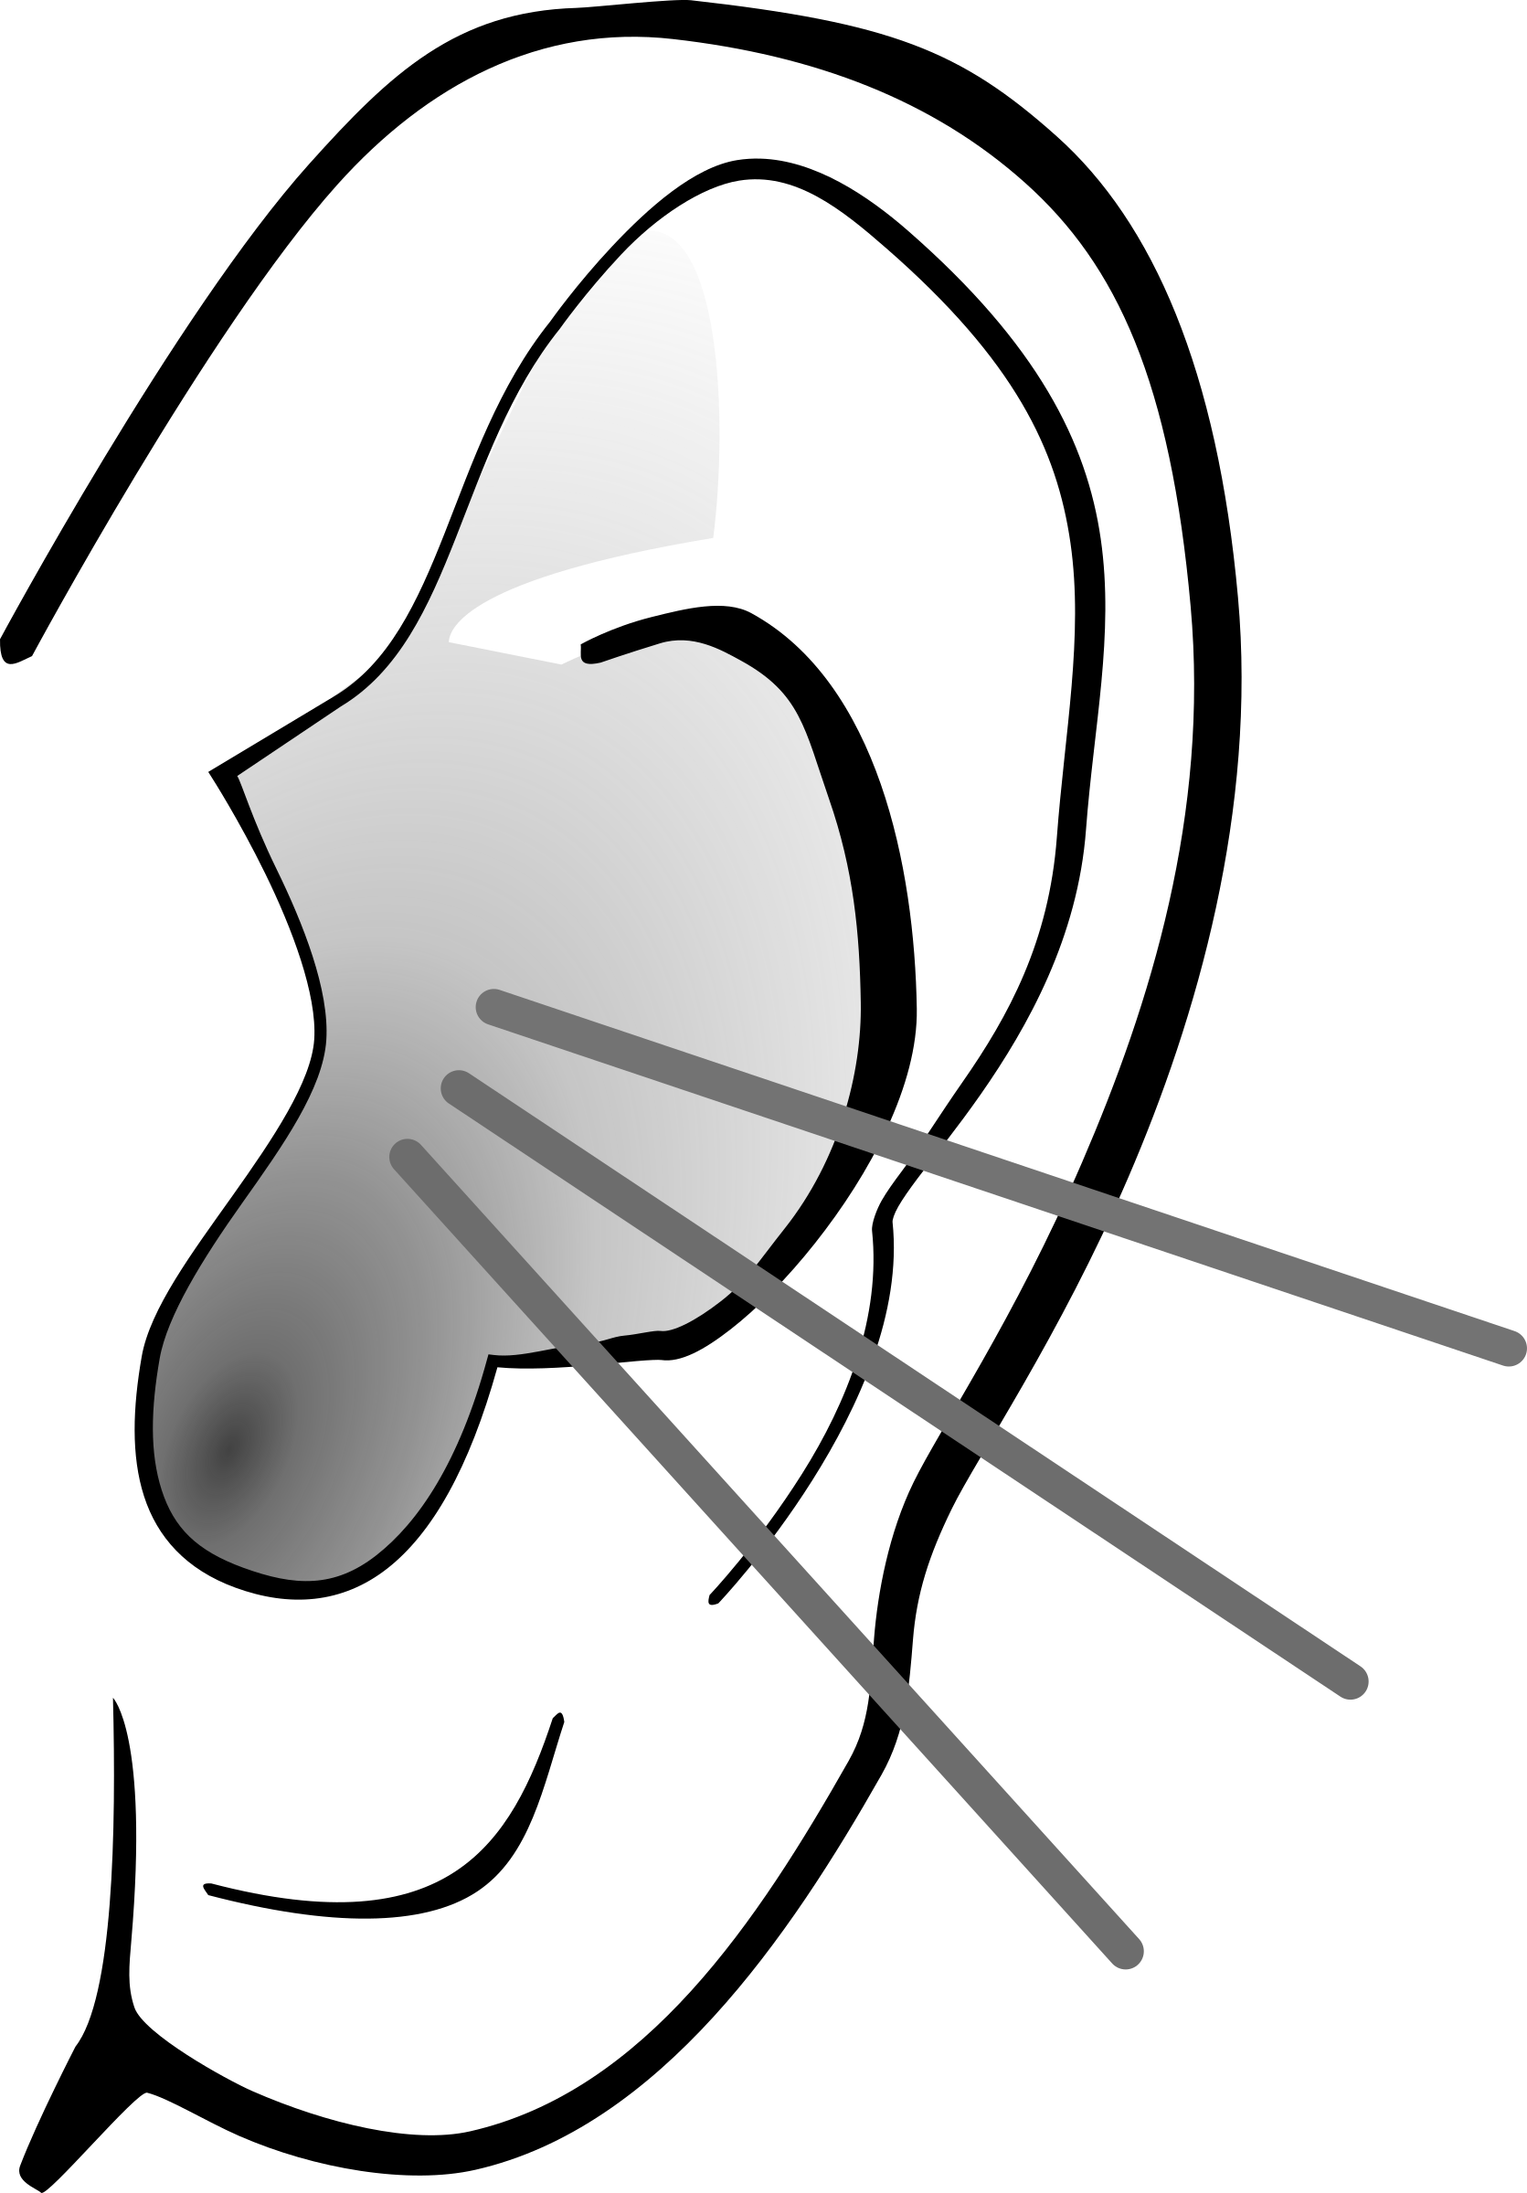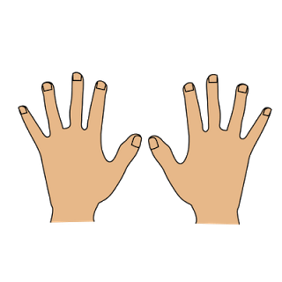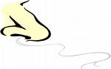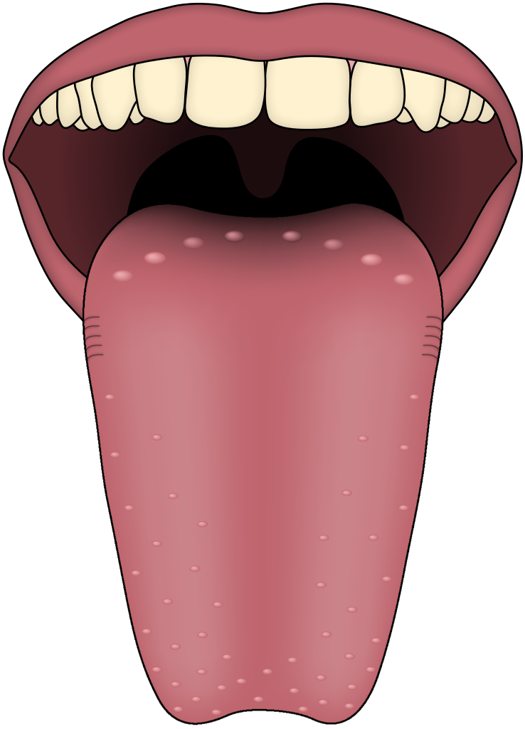
FS Harvest Celebration:
Wednesday 9.15am in The Hall
All FS parents and family welcome

In Mathematics we are learning to:
- Find shapes in the environment.
- Count forwards and backwards to 20
- Recognise what a given number looks like

This week’s school value: Belonging
In Literacy we are:
- Practicing drawing and writing initial sounds.
- Practising s, a, t, p letter formation.
- Story – Peace at Last
PE is every Wednesday!

