Foundation Stage

Topic Guide

Spring Term 2 –

Explorers: Nature Detectives

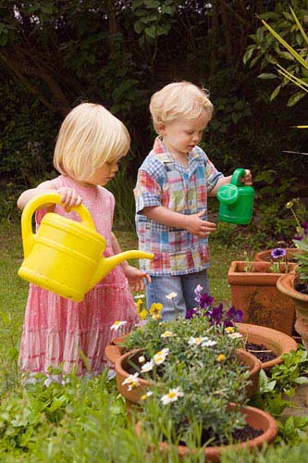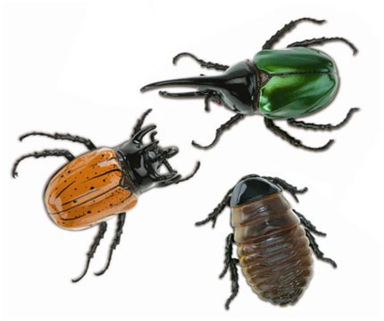

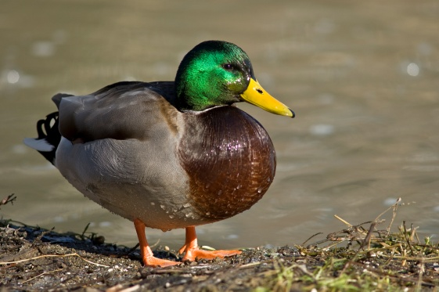

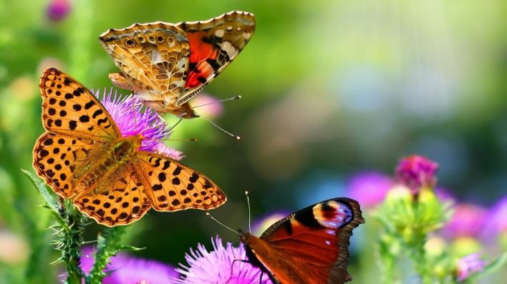

Our topic in Foundation Stage this half term will be ‘Nature Detectives’.

During this topic we will be finding out about animals from around the world following the children’s interests. We will explore where animals live and their different types of habitats. We will find out about what animals need to survive and how they change and grow.

During the topic we will also explore: minibeasts, plants and water. The children will be planting lots of different things and watching them carefully as they grow. We will discuss what plants need to grow and learn about their life cycle. The children will be learning about water and how important it is to us.

In maths we will be continuing to learn about the number system and counting and reinforcing addition and subtraction. We will investigate symmetry, pattern and halving and quartering shapes. We will also be recognising and using coins.

We will explore different types of art and using a range of materials to create animal pictures. We will use ICT programmes to make images of animals. We will listen to different songs and music and create dances based around animals and big and small movements.

We will look at a variety of Bible stories – the Creation and Noah’s Ark as well as animal stories from other religions.

This half term we will be looking at Aesop’s Fables as well as authors Nick Butterworth and Eric Carle, so please look out for these books at the library and share some of them together at home.

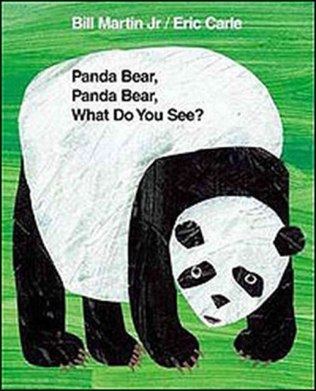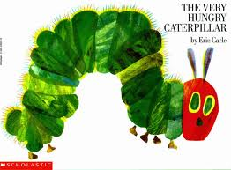[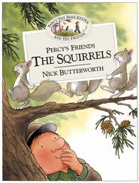](http://www.google.co.uk/imgres?q=nick+butterworth&hl=en&biw=1366&bih=615&gbv=2&tbm=isch&tbnid=RK2wYa3sQD0YHM:&imgrefurl=http://www.harpercollins.co.uk/Titles/16321/percys-friends-the-squirrels-nick-butterworth-9780007119806&docid=VeFPcB517ivrzM&imgurl=http://images.harpercollins.co.uk/hcwebimages/hccovers/016300/016321-FC50.jpg&w=500&h=658&ei=g0nzTtPEHY2o8AO1-dnCAQ&zoom=1)

Places to Visit

**Tring Museum**,   
The Walter Rothschild building  
Akeman Street  
Tring  
Hertfordshire  
HP23 6AP

**Whipsnade Zoo**

ZSL Whipsnade Zoo  
Dunstable  
Bedfordshire LU6 2LF

**Natural History Museum**

Cromwell Road, South Kensington, London

<http://www.nhm.ac.uk/>

**Kew Gardens**

Kew Gardens is located at Kew, Richmond, Surrey, TW9 3AB

<http://www.kew.org>

**Waddesdon Manor**

Waddesdon, Nr Aylesbury, Buckinghamshire, HP18 OJH

01296 653226

<http://www.waddesdon.org.uk/>

Please let us know if you discover any other worthwhile places to visit!

Useful websites:

http://www.dltk-kids.com/animals/

<http://www.enchantedlearning.com/subjects/animals>

<http://www.woodlands-junior.kent.sch.uk/besmart/animals.html>

<http://www.rspca.org.uk/education/utilities/gallery/contents/-/album/WildAnimals>

http://www.bbc.co.uk/schoolradio/subjects/english/aesops_fables

<http://www.eric-carle.com/home.html>

<http://www.highlandschools-virtualib.org.uk/primary_curriculum/minibeasts.htm>

<http://www.bbc.co.uk/cbeebies/somethingspecial/stories/mrtumbleandtheminibeasts/>

<http://www.dltk-kids.com/crafts/insects/index.htm>

<http://tlc.howstuffworks.com/family/easy-water-activities-for-kids.htm>

<http://www.kidzone.ws/water/>

Activities for Parents and Children to share at home

The activities listed below are suggestions for things you might like to try with your child at home. The activities will complement the work we are doing in class. It is not expected that everyone will try all of the activities.

* Make an animal sculpture out of plasticine, play dough boxes, paper or cardboard.
* Collect some natural materials such as stones, leaves and sticks. Use them to make a collage of an animal.
* Paint or draw a picture of your favourite animal.
* Make up an animal story to tell
* Research about the different animals and create a fact file about them to share.
* Make an animal or minibeast mask
* Gather animal toys or pictures – put into order of height, smallest to tallest, sort into groups – big and small or challenge to think of own ways to sort
* Find out the names of animals and their babies
* Count in twos, just like Noah counted the animals in his Ark
* Make an animal home or a bug hotel.
* Make an egg box caterpillar.
* Print finger print bees and some flowers for them to visit.
* Learn a song or rhyme about a bug or a slug.
* Go on a butterfly, caterpillar or minibeast hunt in your garden – www.naturedetectives.org.uk
* Make a weather chart for the week and plot the weather.
* Fill glass jars with differing amounts of water and hit them with a spoon. Discuss why they make different sounds.
* Plant some seeds and watch them grow.
* Make a diary of your plants as they grow.

# Animal Sock Puppets

# Sock puppets inspire hours of imaginative play.

Goofy Gator Sock Puppet

[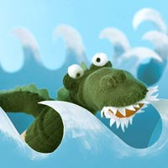](javascript:void(0))This alligator has a bark worse than its bite. Its seemingly sharp teeth are nothing more than soft white felt.

What You Need:[close](javascript:void(0))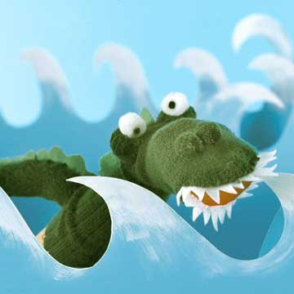

* Green socks
* Scissors
* Green felt

Instructions:

* 1. **To form the mouth,** cut along the toe seam of a green sock, and then sew a red felt oval to the opening and add teeth around the edges.
* 2. **Cut a tail, round eyes, and a nose** from the matching sock, stuff the pieces with batting, and stitch onto the puppet. Stitch a green felt zigzag strip down the gator's back and tail.

Try these fun experiments at home!

**Cold and hot**

Explain to your child that cold water is heavier than warm water. Fill a large bowl or aquarium halfway with warm water. Add red food colouring until the water is saturated with colour. Next, fill a jug with cool water and ice cubes. Stir the water until the ice melts, then add blue food colouring. Ask your child to guess what will happen when you add the cold water to the warm, and then slowly pour in the cold water. The blue water should sink and form a layer under the red water.

**Mixing**

Put out small bowls of materials such as flour, sugar, paint, sand and oil. Give your child a small bowl of water and ask him to choose a material to mix with his water. Encourage your child to first make a prediction about what will happen when he combines it with water. Give him plastic spoons or let him use his fingers to mix the two materials together. Discuss the results.

Useful Information

Welcome back! We hope you have had a relaxing and enjoyable half term. Please find some information below which we hope you will find useful.

Reading is taught throughout the week in our class and group lessons and specifically during Group Time Sessions. Additionally, individual reading books are changed on a Monday and a Thursday by the class teacher and teaching assistant who may also listen to your child read.

We are beginning to start Guided Reading with the children which will be carried out in small groups. We will be developing the children’s comprehension as well as teaching and using decoding strategies.

**Paediatric First Aiders In Foundation Stage**

Catherine Zucconi

Joe Beattie

Tracy Kernan

**Managing Medicines**

Tracey Dale

**Allergens**

|  |  |  |  |
| --- | --- | --- | --- |
| **Malleable** | Containing gluten | Sesame |  |
| Play dough flour | Wheat |  |  |
| Pasta | Wheat |  |  |
| Rice | Wheat |  |  |

The Foundation Stage Team