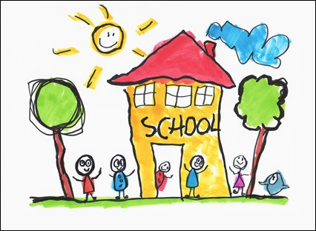
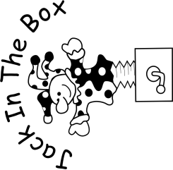

My School Transition Booklet
My name is

This is me

- I like coming to Preschool.
- I can say goodbye to my parent/carer and walk into preschool confidently.
- I can find my name label when coming into preschool

Observation

- I can let my Preschool teachers know what it is I need
- I can go to the toilet by myself and wash and dry my hands
- I can change my own clothes when I need to and I can put on my own coat and shoes.

Observation

- I can sit still and focus for a short amount of time
- I can follow simple instructions
Observation

- I like to play with my friends at Preschool and I can be kind.
- I like to take turns.
- I know if my actions make my friends happy, sad or cross and I am aware of the consequences of my actions.
Observation

- I like to look at books
- I can hold a book and turn the pages by myself
- I can tell you what I think about books and stories
- I can talk about pictures in a book and can tell you the story from the pictures
Observation

- I can tell you a story
- I know some nursery rhymes
My
Nursery Rhymes I know
My story

Here are some examples of my mark making

Observations (concentration, L/R hand, pencil grip, interests, starting to form recognisable letters, talk about what my marks, shapes, letters and pictures mean)
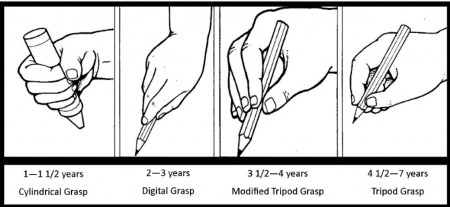

- I can hear and tell you the first sound in a word when you say the word
- I can tell you some words that rhyme with other words e.g hat and cat
- I can hear the word you are saying e.g c-a-t
- I can tell you the sounds of letters in a word e.g dog or ten
- I can write some letters
Observations

- I can use scissors
- Rip
- Snip
- Fringe
- Cut straight lines
- Make zig zag lines
- Cut squares and rectangles
- Cut circles, hearts or curved lines
Observation:

- I know these colours

Other colours I know

- I know these shapes

I can tell you more shapes I know

- I know numbers
- I can recite numbers in order
- I can count object
- I can use mathematical language when I’m playing
- I can recognise some numbers
Observations

What I would like my new teachers to know about me……..

