Stories From Around The World

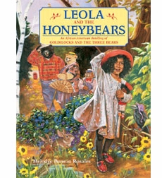 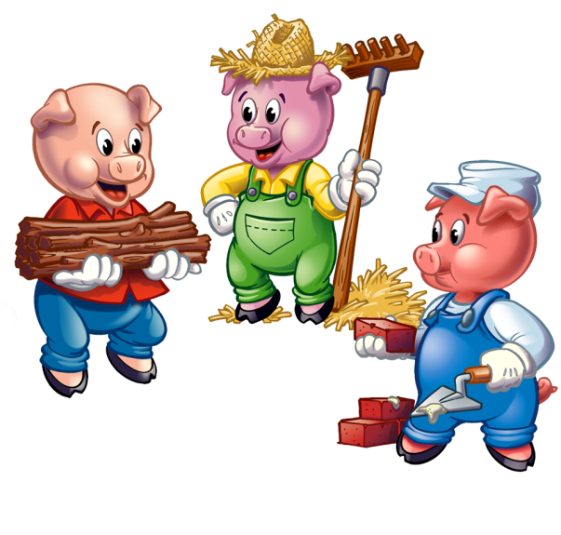

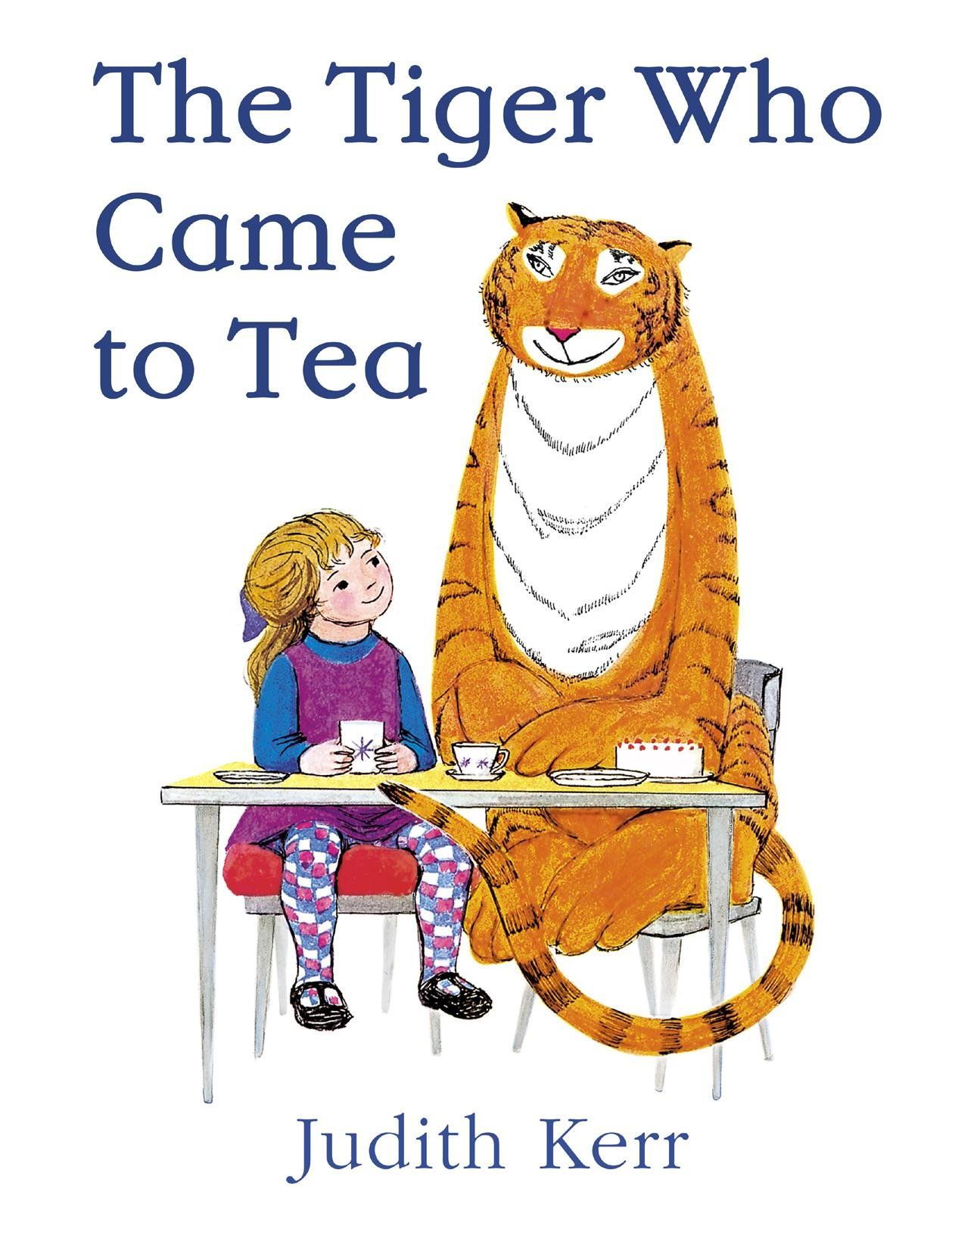

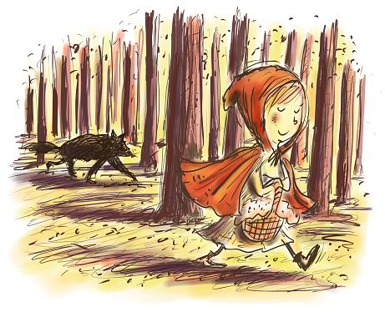 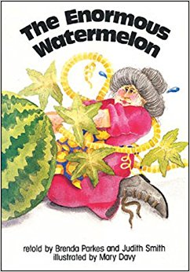

Foundation Stage Summer Term

Topic Guide

Our topic this term is ‘Stories From Around The World’. Throughout the term we will be looking at different stories, stories structures, story language, the message behind them, the characters, caring, sharing and looking out for each other.

We cannot quite believe that this is our final term in the Foundation Stage. We have planned many exciting activities for the term, focused around stories. We will be organising a ‘The Tiger who came to Tea’ Fun Day at school during the last half term.

During Summer 1 we will be learning about and reading lots of traditional tales as well as stories from different cultures as well as poems and nursery rhymes. We will then continue our story topic and Julia Donaldson will be our key author. If you have any favourite story books to share, please send them in with a name in the front or back and we will enjoy sharing them with the class. We will also have focus stories each week.

If you require any further information or have any concerns, please do not hesitate to talk to us.

Mrs Shrimpton, Mrs Nelson and Mrs Mills

Activities to try at home....

* Read traditional stories, rhymes and poems and discuss messages – how it is important not to talk to strangers (Little Red Riding Hood)
* Discuss and describe characters from different stories
* Talk about where the stories take place
* Sequence the stories – what happens next?
* Make up your own stories-change the endings or the characters of familiar stories
* Make gingerbread men, measuring ingredients
* Make porridge
* Read stories from different cultures
* Search for different countries on maps and atlases
* Make tiger puppets or masks
* Design clothes for Cinderella or the Princess so they can go to the ball
* Create paper bag or kitchen roll fairy tale story characters

Useful websites:

<http://www.juliadonaldson.co.uk/>

<http://www.bbc.co.uk/cbeebies/stories>

<https://www.oxfordowl.co.uk/for-home/reading-owl/library-page>

Useful Information

Welcome back! We hope you have had a relaxing and enjoyable Easter. Please find some information below which we hope you will find useful.

Reading is taught throughout the week in our class and group lessons and specifically during Group Time Sessions. Additionally, individual reading books are changed on a Monday and a Thursday by the class teacher and TAs who may also listen to your child read.

We will continue with Guided Reading with the children which will be carried out in small groups. We will be developing the children’s comprehension as well as teaching and using decoding strategies.

**Paediatric First Aiders In Foundation Stage**

Catherine Zucconi

Joe Beattie

Tracy Kernan

**Managing Medicines**

Tracey Dale

**Allergens**

|  |  |  |  |
| --- | --- | --- | --- |
| **Mallable/creative** | **Containing Gluten** | **Sesame** | **Egg** |
| **Play dough** | **Wheat ✓** |  |  |
| **Pasta** | **Wheat ✓** |  |  |
| **Rice** | **Wheat ✓** |  |  |
| **Cooking** | **Containing Gluten** | **Sesame** | **Egg** |
| **Gingerbread Men** | **Wheat ✓** |  | **✓** |
| **Sandwiches** | **Wheat ✓** |  |  |
| **Pitta, bread houmous, carrots and cucumber** | **Wheat ✓** | **✓** |  |

The Foundation Stage Team

**Story Telling**

Our topic this term involves reading and writing many different stories. Throughout the term we will be reading and writing:

* Short stories
* Stories with repeated patterns/ repeated refrains

We have already been thinking about how different stories are structured in terms of all stories having characters, a setting, a problem and a resolution. We have looked at a ‘Tales Toolkit’ (a toolkit for creating tales) using the power of story to engage children. There are easily recognised symbols for the character, setting, problem and solution giving the children skills to independently weave magical tales. Using the symbols means all children can easily understand and remember the story structure.

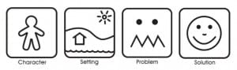

We have added another symbol in between the setting and problem called ‘the build up’ as we found that the children were naturally building their stories before the problem.

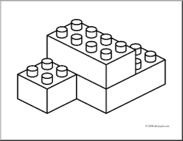

Build up

Here is an example of a story told by a four year old in Foundation Stage:

“A long time ago there was a little boy who lived in a forest. One day the little boy was walking along the path. But a troll came along. So the little boy ran away. The end.”

We have a daily story time where we discuss different characters, settings and story language. Here are some examples of the different language we will be continuing to use during the term:

Start

|  |  |
| --- | --- |
| Once upon a time | Early one morning |
| One sunny day | One wintry day |
| Long, long ago | Many years ago |

Build up

|  |  |
| --- | --- |
| One day | One afternoon |
| Before long | Late one night |

Problem

|  |  |
| --- | --- |
| But | Suddenly |
| Unluckily | Unfortunately |

Solution

|  |  |
| --- | --- |
| So | |
| Luckily | Fortunately |

Ending

|  |  |
| --- | --- |
| In the end | And that was the end of that |
| Finally | Four leaf clover, the story is over. |

We anticipate that children will add in other details that feature within our story telling sessions – alliteration, onomatopoeia words, adjectives and similes as these are often discussed when sharing stories. At the end of the year the story may sound like this.

“Many years ago there was a little boy who lived in a deep, dark forest. Late one night the little boy was walking along the path. Suddenly a huge, giant troll appeared and wanted to eat the little boy in one big gulp. MUNCH! Luckily the little boy ran away as fast as a hare. In the end the little boy didn’t go out at night on his own.”

Some children are already starting to show an interest in recording their stories after they have told them and have the symbols next to them as a reminder. Please find attached a couple of templates that you could use at home should you wish to.

We will also continue to read stories with repeated patterns or repeated refrains, for example, “But he was still hungry,” from the Hungry Caterpillar, or “they pushed and they pulled but it wouldn’t budge” from The Enormous Turnip. The children often start to add these phrases into their stories.

We would love to hear or see the stories children are writing at home.

Happy story telling.

|  |  |
| --- | --- |
| Character |  |
|  |
| Setting |  |
|  |
| https://encrypted-tbn2.gstatic.com/images?q=tbn:ANd9GcTyZrBUgu1TNbU4gBvVaTiTmRvzLfYEUn8k-w8mO9O3bRWlDqWWOF9NYGuy  Build up |  |
|  |
| Problem |  |
|  |
| Solution |  |
|  |